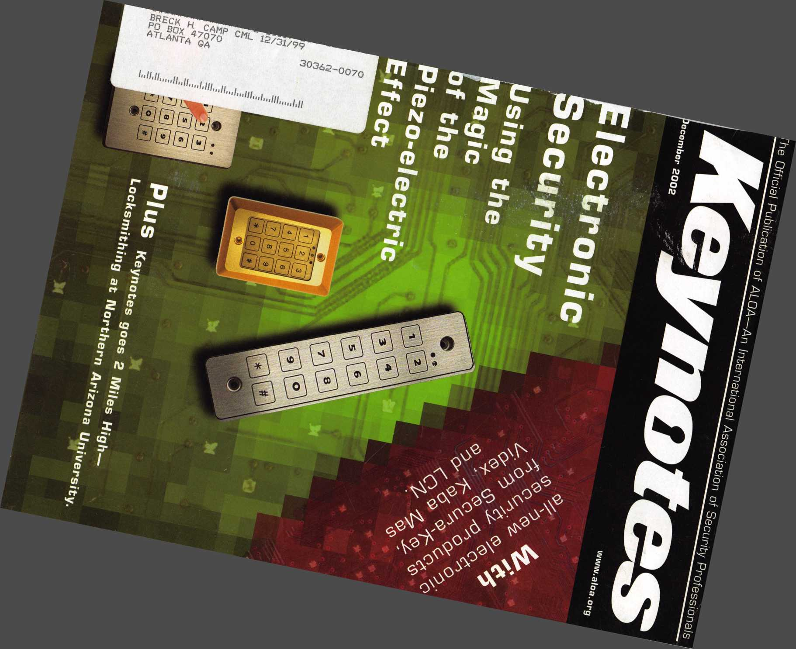

Keep Your Day Job

Come to Las Vegas and invest in your future as a security professional.

Discover classes, workshops, and exhibits that will keep you competitive in today’s marketplace.  
Las Vegas Hilton/Las Vegas Convention Center •July 14-20, 2003

The only gamble is staying home

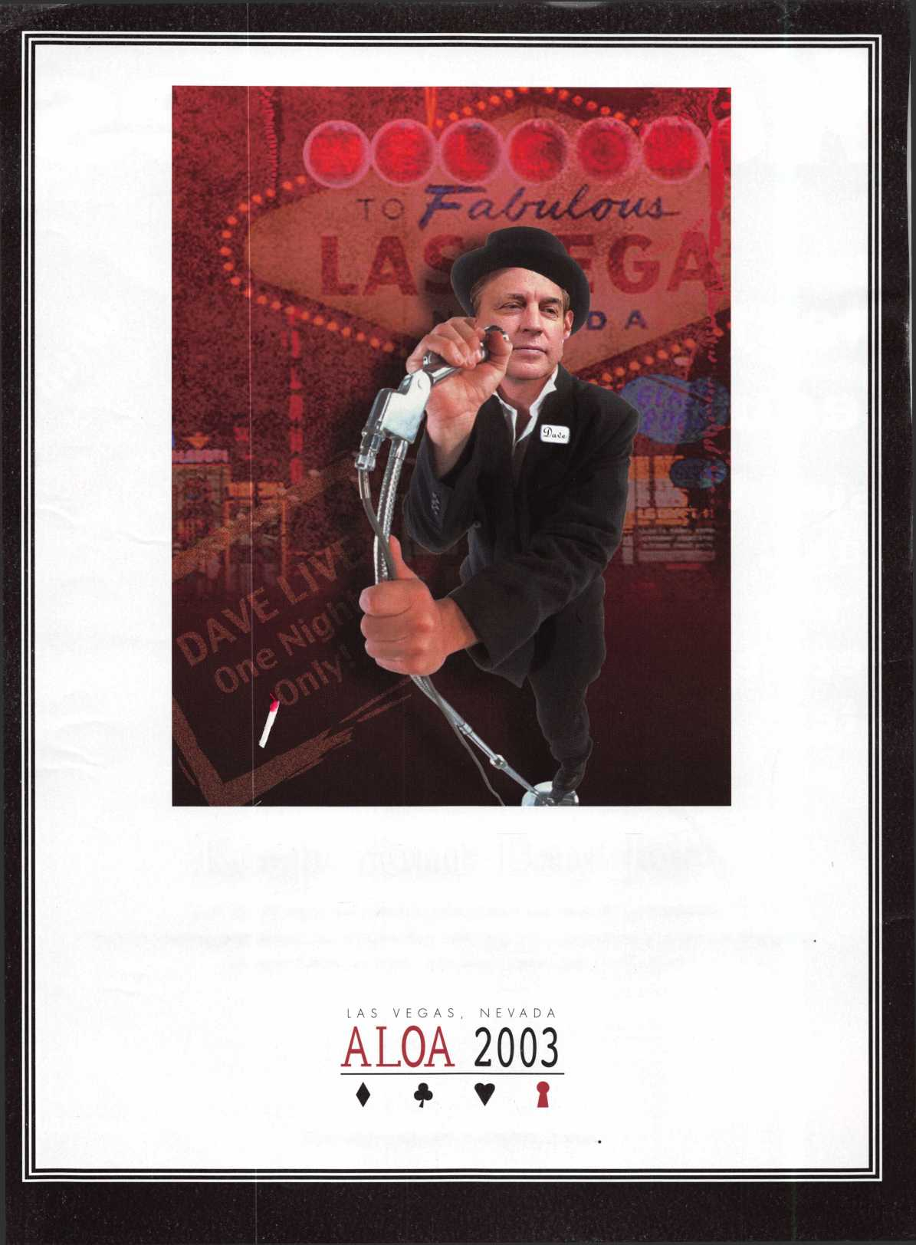

**Products** **LOCKSMITH Professionals**

***far***

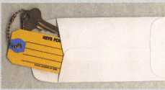

ANDOVER LOCK & KEY SERVICE

3221 LAKESIDE HWY.  
ANDOVER MA 05242  
(508) 626-1111

**AD / ID KEY TAGS**

Specifically designed to identify the product you work with daily and promote your business with your custom Ad copy.

back side of tag with 4 lines for key identification

KEYS FOR

Clear Plastic Protective Sleeves Stock# PPS10

Protect your key tags with  
durable plastic sleeves

**Key Tag Envelopes**

Stock # KTE3 Actual Size: 2%" x 4W Added security and finishing touch when presenting keys to your customers

* 100 200 500 1000

10.50 17.00 37.50 65.00

* 100 200 500 1000

11.50 19.95 42.00 68.50

TO ORDER: Choose QTY.,  
Key Tags with Chains or  
Rings, TAG COLOR and  
Provide Imprint Copy

(printed black only).

QUANTITIES

**FREE Printing of Your Ad Copy on bac**

W*.

LAKE VIEW LOCKSMITH

24 Hour Service (845) 556-LOCK

Choose from Brass Plated Bead Chains or Chrome Plated Wire Rings

1000

2000

3000 5000

* KEY TAGS with CHAINS or RINGS 32.00 42.95 83.95 115.00 195.00 269.00 395.00

YOUR CHOICE OF CHAINS OR RINGS - IF NOT SPECIFIED WE SHIP CHAINS

Key Tags Only (no chains or rings) - Deduct 10% from above prices

National Logos - No Charge / Custom Logos - Add $25.00 and supply clean B & W artwork

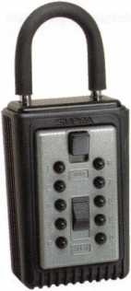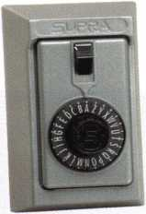

**COMBINATION KEY BOXES**

©SUPRA

ALL METAL

PROFESSIONAL

**PUSHBUTTON**

1-4 37.95 EA. / 5-9 34.95 EA.  
10 or MORE 31.95 EA.

**Set your own combination**

The combination can be changed in seconds — without special tools or disassembly. Changing the shackle combination also automatically changes the combination for the sliding key storage door.

SERIES LOCK BOXES

Both models now have weather resistant  
ALL TITANIUM METAL CONSTRUCTION  
with metal back and buttons. Both models  
are also available with PUSH BUTTON  
COMBINA TION LOCKS that are easy to  
set & reset.

**DIAL**

1-4 36.95 EA. / 5-9 33.95 10 or MORE 30.95 EA.

**Stock #S5-DIAL** Surface Mount Unit

**No Home Should Be Without One**The Surface-Mount S-5 Supra  
Lockbox is a product you can provide to  
any homeowner, easily priced to your  
customer in the $50.00 range installed  
(simple 4 screw installation). Carry one

with you at all times to demonstrate - **stock # S5-PUSHBUTTON**once shown it sells itself!! Surface Mount Unit

Key Storage Lock Box

t/ALL METAL Construction

* Great Economical Pricing
* Simple to set/ Simple to open
* 5 Year Warranty

ShurLok has designed an all-metal key storage box that is the safest, most secure lock box on the market. Separate easy to set combinations open the shackle and key compartment — and the combinations can be changed in seconds. The ShurLok is so simple to use a child can open it, yet so versatile it will satisfy the Real Estate professional or anyone requiring key access in a lock box. Unique double combination allows all users access to key(s) while allowing only authorized users access to the shackle and will prevent lock box removal or theft.

1 to 9 $19.95 ea. Stock#SLK100R

10 or more $17.95 ea.

*if color is not specified we ship blue*

**Stock #C3-PUSHBUTT0N**

Removable KeyBox, DoorGuar rubber bumper protects surfaces

**Stock #C3-DIAL**Removable KeyBox  
DoorGuard rubber bumper protects surfaces

change

button

|  |  |  |
| --- | --- | --- |
| llciiii) |  | 1 |
| l ) |  |  |

**10,000**

Combinations

Possible!

Changing the combination

for the shackle

t only takes a few seconds

with a simple turn  
of the change button.

Stock # SLK100  
Blue

**\*$7.00 SHIPPING CHARGE ADDED PER ORDER** ny residents add applicable sales tax

**SANZO SPECIALTIES, INC. TOLL FREE: 1-800-222-4041**

**BOX 68 ENDICOTT, NY 13760 FAX: 607-748-0507**



***V/SA***

***Mast***

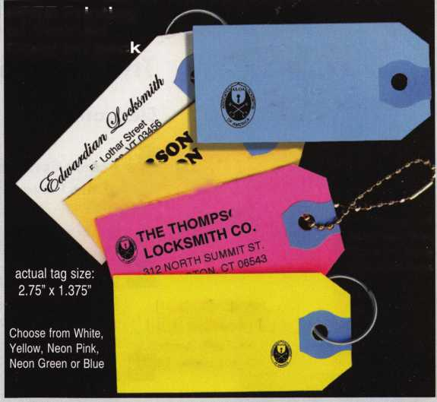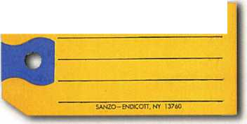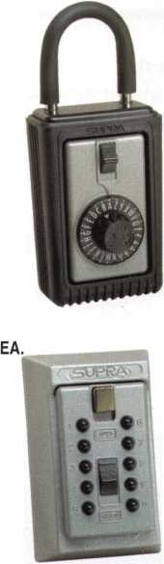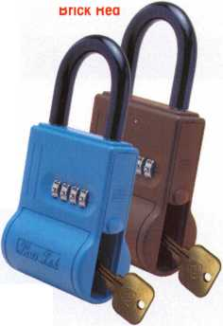

t

u

r

s



e

a

e

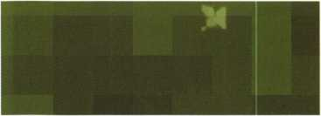

The Electronics Issue

Electronics



Access Control: Using the Magic of the Piezo Effect

Secura-Key offers some new electronic access control key pads using "Piezo" technology. In other words, these pads are tough as nails.

Basics: The LCN Electronic Door Closer

The Auto-Equalizer Model 4820 is a non-handed, non-sized, low-energy door operator - and its pneumatically operated to boot.



Safes: Locked Open?

Customer Blunder Brings Us Inside the Cencon ATM Electronic Lock



Mechanical: Videx Cyberlock, Part 1

The Cyberlock from Videx combines electronic and physical security in a tiny little package. Here's a look inside it.

By Paul Chandler, CRL

By Dave Thielen, CML

By Greg Perry, CML, CPS

By Sal Dulcamaro, CML



Institutional:

2 Miles High: Institutional Locksmithing at Northern Arizona University

(Interview with Chuck Snelling, CML)

Business



The Evolution of a Unique Rolling Keyboard (Part 1)

When space and practicality are a concern, one ALOA member learned how to roll with the punches. Here's how he did it.

By John Dorsey, CML, CPS



Executive 3 Applicants 6 Legislative Classifieds 40 BackPage 44

Calendar 10 Core 8 Update 36 Associate

Members 42



Visit our

w e

b s i t e at

WWW

a

I o a

o r g

Keynotes • December 2002

**executive**

Volume 48, Issue 11

Additional contact information for the ALOA Board and most Keynotes authors is  
available through "Locksmith Search'" on the ALOA Web site- [www.aloa.org](http://www.aloa.org) or by  
contacting the ALOA office at 3003 Live Oak Street; Dallas, TX 75204; (800)532-2562;  
FAX (214)827-1810; e-mail [aloa@aloa.org](mailto:aloa@aloa.org).



Editor

Jim DeSimone [editor@aloa.org](mailto:editor@aloa.org)

Technical Editor

David Lowell, CML, CMST [david@aloa.org](mailto:david@aloa.org)

Editorial Advisor

John D. Cannon, CML [jdcannon@worldnet.att.net](mailto:jdcannon@worldnet.att.net)

Art Director

Betty Henderson [betty@aloa.org](mailto:betty@aloa.org)

Advertising Sales

Kim Hammond voice: 817-645-6778

Fax: 817-645-7599  
e-mail: [adsales@aloa.org](mailto:adsales@aloa.org)

Executive Director

Charles W. Gibson, Jr., CAE

PRP/Education Manager

David Lowell, CML, CMST ..

Contributors

Jerome Andrews, CML  
Paul Chandler, CRL  
Claire Cohen, CML  
Brian Costley, CML, CMST  
Ray D'Adamo, CML

[charlie@aloa.org](mailto:charlie@aloa.org)

.[kelly@aloa.org](mailto:kelly@aloa.org)

.[david@aloa.org](mailto:david@aloa.org)

Sal Dulcamaro, CML Billy Edwards, CML Dan Graffeo, CRL,CMST AJ. Hoffman, CML Jeff Nunberg, CML, CMST

Convention & Meetings Manager

Kelly Carr, CMP

Operations/Membership Manager

Mary May [mary@aloa.org](mailto:mary@aloa.org)

Director of Information Technology

Randy McChristian [randy@aloa.org](mailto:randy@aloa.org)

Government Affairs Manager/

Chapters & Regional Associations Liaison

|  |  |
| --- | --- |
| Tim McMullen | [tim@aloa.org](mailto:tim@aloa.org) |
| Comptroller | Kathy J. Romo |
| Network Specialist | Greg Jackson |
| Membership Coordinator | Shelly Jett |
| Convention & Meetings Assistant Karen Lyons | |
| PRP/Education Coordinator | Ashley Manson |
| Accounting Coordinator | Stephanie Brothers |
| Mail Room Coordinator | Kevin Wesley |

Mike Oehlert, CPL, CPS Randy Simpson, CML Robert Stafford, CML Dave Thielen, CML Greg Perry, CML,CPS

Tom Seroogy Charles Stephenson, CPS Dennis Watanabe, CML, CMST

Mission Statement: The Associated Locksmiths of America, Inc. is dedicated to enhancing the professionalism, education and ethics among locksmiths and those in related sectors of the physical security industry. With approximately 10,000 members in the United States, Canada and the freeworld, ALOA is poised to help members obtain the knowledge, the strength, and the confidence to perform their role in the physical security field with pride and dignity. But it is only through active involvement and participation that ALOA can fully achieve its potential—and can help members to achieve theirs.

Policies: **Keynotes**® is the official publication of the Associated Locksmiths of America, Inc. (ALOA). **Keynotes®** acts as a moderator without approving, disapproving, or guaranteeing the validity or accuracy of any data, claim, or opinion appearing under a byline or obtained or quoted from an acknowl­edged source. The opinions expressed by the authors do not necessarily reflect the official views of ALOA. Also, appearance of advertisements and new products or service information does not constitute an endorsement of products or services featured by the Association. The Association does not accept responsibility for the inaccuracy of any data, claim, or opinion appearing in this publication, due to typographical errors on the part of the authors, Association staff or its agents.

Editor's Note: This publication is designed to provide accurate and authoritative information in regard to the subject matter covered. It is provided and disseminated with the understanding that the publisher is not engaged in rendering legal or other professional services. If legal advice and other expert assistance is required, the services of a competent professional should be sought.

Authors' Payment: Payment for eligible submissions to Keynotes will be based on the following criteria: topic, time spent and past contributions. Authors who regularly submit to **Keynotes**® are generally paid a higher rate. The latter is especially true of authors who write to fit specific editorial needs and submit said copy by **Keynotes**® deadlines. As a general guideline: Average payment for a 750 word, business or 'light' technical article would be $200. Payment for a 1500 word article involving significantly higher time and research efforts would be $400.

Payment will not be offered for articles submitted by ALOA employees or members of the ALOA Board of Directors (unless material is of a technical nature), nor for articles submitted by a company that promote that company's products or services. ALOA reserves the right not to pay for articles sub­mitted by an individual(s) that promote a particular company's products or services.

Disclaimer: The Associated Locksmiths of America, Inc., (ALOA), reserves the right to refuse any article for any reason. Additionally, ALOA reserves the right to edit, amend or modify any article submitted for publication in order to preserve technical accuracy, clarity, fairness or grammatical cor­rectness. ALOA will make the best efforts to notify the author of any changes. The extent of ALOA's liability for any article or information contained therein will be a notice of correction or retraction in the next possible issue.

**Keynotes**® (ISSN 0277 0792) is published monthly except for the combined June/July issue by The Associated Locksmiths of America, Inc., 3003 Live Oak St., Dallas, TX 75204-6186. Telephone: (214) 827-1701; FAX (214) 827-1810; e-mail [aloa@aloa.org](mailto:aloa@aloa.org). Subscription rates for members—$15.00 per year. Second class postage paid at Dallas, Texas. POSTMASTER: Send address changes to: Keynotes, 3003 Live Oak St., Dallas, TX 75204-6186. © Copyright 1999, All rights reserved. No part of the contents may be reproduced or reprinted in any form without prior written permission of the publisher.

President

Randy Simpson, CML

1. 780-7026

[president@aloa.org](mailto:president@aloa.org)

Secretary

John D. Cannon, CML  
(703) 960-6413

[secretary@aloa.org](mailto:secretary@aloa.org)

Directors, Northeast

Robert E. Mock  
(215)624-5035  
[nedirector@aloa.org](mailto:nedirector@aloa.org)

Peter Sarailian, CRL  
(973)890-9797  
[nedirector@al6a.org](mailto:nedirector@al6a.org)

William L. Young, CML  
(610) 647-5042  
ned i rector@a loa. org

Directors, Southeast

Vincent Formon, CML, CPS  
(901) 324-2910  
[sedirector@aloa.org](mailto:sedirector@aloa.org)

Donald E. Rule, CML  
(662) 324-2658

V ‘ [sidtrector@afeS.org](mailto:sidtrector@afeS.org)

Directors, North Central

Mark E. Blum, CML, CPS  
(517)482-5809  
[ncdirector@aioa.org](mailto:ncdirector@aioa.org)

John Soderland, CML, CMST (414) 327-5625 ; [ncdirector@aloa.org](mailto:ncdirector@aloa.org)

Director, South Central

CD Lipscomb, CML, CPS  
(903)874-3522  
[scdirector@aloa.org](mailto:scdirector@aloa.org)

Directors, Southwest

Gordon R. Racine, CML  
(719) 384-4707  
[swdirector@aloa.org](mailto:swdirector@aloa.org)

Julie McCluney, CRL

1. 636-5652 [swdirector@aloa.org](mailto:swdirector@aloa.org)

Director, Northwest

Scott L. Henke, CRL, CPS  
(907) 248-3785  
[nwdirector@aloa.org](mailto:nwdirector@aloa.org)

Director, European

Hans Mejlshede, CML  
(453)539-3939  
[eurdirector@aloa.org](mailto:eurdirector@aloa.org)

Director, Asian

joej. Lee, CRL  
(215)289-2404  
asiandirector@aloa .org

Director, Associate

Paul M. Justen  
(800)333-6953

[asdirector@aloa.org](mailto:asdirector@aloa.org)

Trustees

[trustees@aloa.org](mailto:trustees@aloa.org)

John J. Greenan, CML, CPS  
(773) 486.2030

Dallas Brooks  
(334) 826-8990

David M. Lowell, CML, CMST  
(800) 532-2562

Past Presidents

1999-2001 John Greenan, CML, CPS  
1997-1999 Dallas C. Brooks  
1995-1997 David Lowell, CML, CMST  
1993-1995 Breck Camp, CML  
1991-1993 Henry Printz, CML  
1989-1991 Evelyn Wersonick, CML, CPS  
1987-1989 Leonard Passarelio, CPL  
1985-1987 Joe Jackman, CML  
1983-1985 Stanley Haney, CPL  
1981-1983 Louis LaGreco, CPL  
1979-1981 John Kerr, RL  
1977-1979 Clifford Cox, CML  
1974-1977 Charles Hetherington  
1972-1974 Gene Laughridge  
1970-1972 William Dutcher, RL  
1968-1970 Constant Maffey, RL  
1966-1968 Harold Edelsteia, RL  
1964-1966 William Meacham  
1962-1964 Robert Rackliffe, CPL  
1960-1962 Edwin Toepfer, RL  
1956-1960 Ernest Johannesen



Keynotes • December 2002

**president**

**journey**

**i**

s

Hello Members,

Totally wired? The corporate side of security is in the process of going digital. LAN this and WAN that. You can have a DVR with a terabyte of storage. Your cards can be HID and SMART. I'm talking about cards that can read and write. On the software side you must have Access unless you have already gone for Sequel. You must have a static IP and CAT 5, or better yet, an optical connection.

If this lingo does not sound familiar, you probably need to get out and look these words up. The digital revolution has started, and is roaring through like a freight train.

Technology has cut the cost of electronic security devices down to the reach of every­day companies. Superior quality products are replacing archaic dinosaurs at a frac­tion of their original price. These products integrate, cooperate and participate with databases that manage and run businesses around the globe. Managers can look up, look in and look out for anyone from the comfort of his or her PC, from either the office or from home.

Maybe it's time you considered upgrading your know-how to match the technologi­cal advances we're experiencing. Best of luck ...

See you next month, Randy Simpson, CML

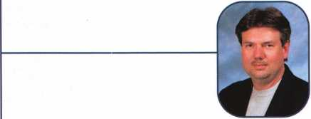

Keynotes • December 2002



***Visit our Website on****[www.stamcctv.com](http://www.stamcctv.com)*

**THE COMPLETE**

**CCTV PROGRAM ON CD-ROM  
FOR STAFF TRAINING AND**

**PRODUCTIVITY ENHANCEMENT**

STAM Insight has been  
developed to enhance CCTV  
skills and productivity with  
many different uses.

# Productivity

4# System Drawing t# Estimation **•** CCTV Training I# CCTV Reference I# Sales/Demo 40 System Design 40 Staff Evaluation

10 hours

14 hours

Estimation

Drawing

CCTV Content

CCTV Calculators

Demonstration Tool

**INFOMATE**

**!0 hours**

**WORKMATE**

*Internet En*abled Pre-Test

Quizzes Knowledge Assessment



3003 Live Oak Street  
Dallas,Texas 75204

|  |  |
| --- | --- |
| ■ Yes, please send me a FREE PREVIEW CD ROM $9.95 S/H | |
| Name: |  |
| Job Title: |  |
| Organization: |  |
| Address: |  |
|  | Zip/Postcode |
| Country | e-mail |
| Tel: ( ) | Fnx: ( ) |
|  | |

COPYRIGHT © 1996 Security Training and Marketing Pty Ltd.  
All rights reserved ACN 057 006 541

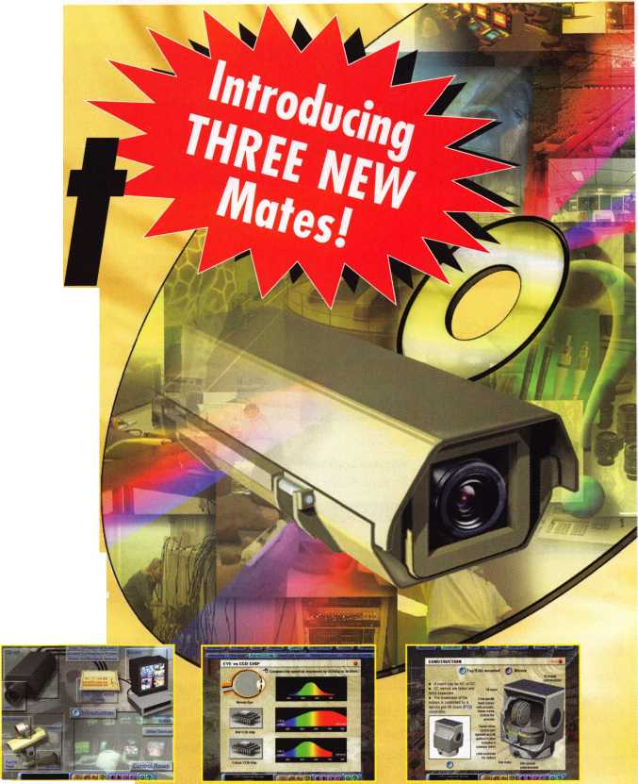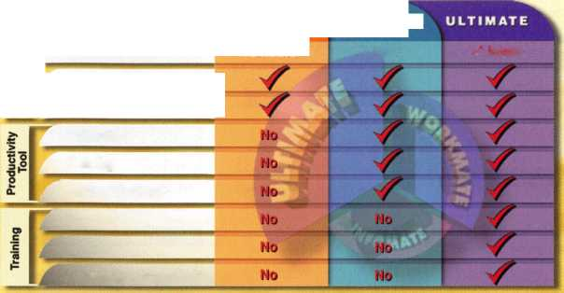

**applicants**

for members1'*

|  |  |  |  |  |
| --- | --- | --- | --- | --- |
| AK | Savannah Northampton | NH | I I | VA |

Fairbanks

Clifford W. Batye

Sponsor: John L Harrell CRL

San Jose

Darrin Wicker

Fort Morgan

Mike Bailey

Sponsor: Kevin R. Silvers CML

Torrington

Douglas M. Dodge

Sponsor: Douglas W. Dodge

Washington Christopher E. Knick

Sponsor: C Allan Halverson Sponsor: Terrence G. Branch

New Castle

Andrew Goodwin

Sponsor: Martin Arnold Sr, CML

New Smyrna Beach Terry Bradshaw

Sponsor: Vincent L Formon CML, CPS

Albany

Freddie P. Smith CPL

Sponsor: Vincent L. Formon CML, CPS

Lawrenceville

Randy W. Horner

Sponsor: Kevin R. Wilson CML

Lilburn

Richard Williamson

Sponsor: Kevin R. Wilson CML

Bruce T. Rahn

Sponsor: Vincent L Formon CML, CPS

Statesboro Horace A. Mixon

Sponsor: William H. Stradling III

Honolulu

Wayne Lockhart

Sponsor: Richard J. Krupa

Osceola

Robert Brownlee

Mishawaka

Alejandro Quintanilla

Wichita

Don Loehr James M. Roberts

Sponsor: James T. Tracy

Lexington

Tim Abner

Sponsor: John D. Cannon CML

Minden

Richard Desadier

Sponsor: Jerry K DeLano CRL

Florence

Richard A. Grenon

Sponsor: Michael A. Nelson

North Andover

Michael Turmel

Sponsor: Joseph A. Dube CML

North Hatfield Mark A. Neal

Sponsor: Michael A. Nelson

Brian P. Dupee

Sponsor: Michael A. Nelson

Randolph Gary Scanlon

Sponsor: Barry McMenimon

Daniel Rosko

Sponsor: Barry McMenimon

Peter Quinn

Sponsor: Barry McMenimon

Mark Lacoste

Sponsor: Barry McMenimon

Joseph Hunt

Sponsor: Barry McMenimon

Brad McMenimon

Sponsor: Barry McMenimon

Mitchellville

James E. Anderson

Sponsor: Vonfranklin Marshall

Detroit

Jamel Hunt

Hopkins

Jeffrey Ha nee

Union

Randy Mize

Horn Lake

Nickles R. Rhoda

Sponsor: C Allan Halverson

Boone

Donald K. Ball

Sponsor: Rickey L Oakes CML

Lincoln

John A. Firestine

Sponsor: Robert L. Schoonover

Conway

Richard L Roderick

Elmwood Park

Daniel C. Counterman

Sponsor: Thomas E. Ware CML

Albuquerque Duana L Boyd

Sponsor: Brian J. Sweeney CML

Carson City

James E. Reading

Freeport

Scott Kinhackl

Sponsor: Heidi Kinhackl

Plattsburgh

Leonard E. Bianco

Portland

Lee Charles Moore Jr

Sponsor: Daniel E. Cunningham CRL

George Inness

Sponsor: Downie W. Dowless Jr, CML, CMS

Providence

Dennis Pereira

Sponsor: Barry McMenimon

Dallas

Dennis W. Moore

Kemp

John A. Hughes

Sponsor: Robert H. Golden CPL

Leesburg

Donald R. Howser

Sponsor: Aaron B. Greenburg

Hartford Peter Deutsch

Sponsor: Russell P. Fuller CRL

Tumwater

Edward C. LeRiche

Sponsor: Randy J. Main

Dublin

William Hamill

Sponsor: Steven E. Sellers

Hokkaido

Hiromasa Kobayashi

Sponsor: Toshihiro Asano

Ibaraki

Hideki Ito

Sapporoshi Hokkaido Susumu Takahashi

Toyonaka City Osaka

Katsumi Mizuhara

Sponsor: Tomoo Hisano

Seoul

Sunny Park

Hertfordshire

Heidi Cummins

Sponsor: Ken Dale

London

Kenneth MacLennan

These applicants are scheduled for clearance as members of ALOA. The names are published for member review and comment within  
30 days of this Keynotes issue date, respectively, to ensure applicants meet standards of ALOA's Code of Ethics. Protests, if any, should  
be addressed to the Membership Department and must be signed. Active Membership applicants (a) have worked in the industry two or  
more years. Allied Membership (AL) applicants are not locksmiths, but work in a security-related field. Apprentice Membership (AP)

applicants have worked in the industry less than two years.



Keynotes • December 2002

nagnBUDiinai mmm

fluailable as single  
modules (one CO and  
guidebook) or the full  
set (three CDs and  
three guidebooks).

Seruer uersions are  
also auailablef

I1TECTURAL DOORS AND HARDWARE FUNDAMf

**Self-Study Course**

FUNDAMENTALS OF:

; ***and Hardwa***

Study Cour<

**mon**

SPECIAL

**Get the award-winning  
*Fundamentals of architecture  
Doors and Hardware Self-Study  
Course* at a great price!**

The ultimate training tool for locksmiths... **Nolu** there is a complete in-house training

**program auailable! Order the** Fundamentals of architectural Doors and Hardware Self

Study Course **three CD/guidebook series.**

To order, call (800)532-2562 or [www.aloa.org](http://www.aloa.org).

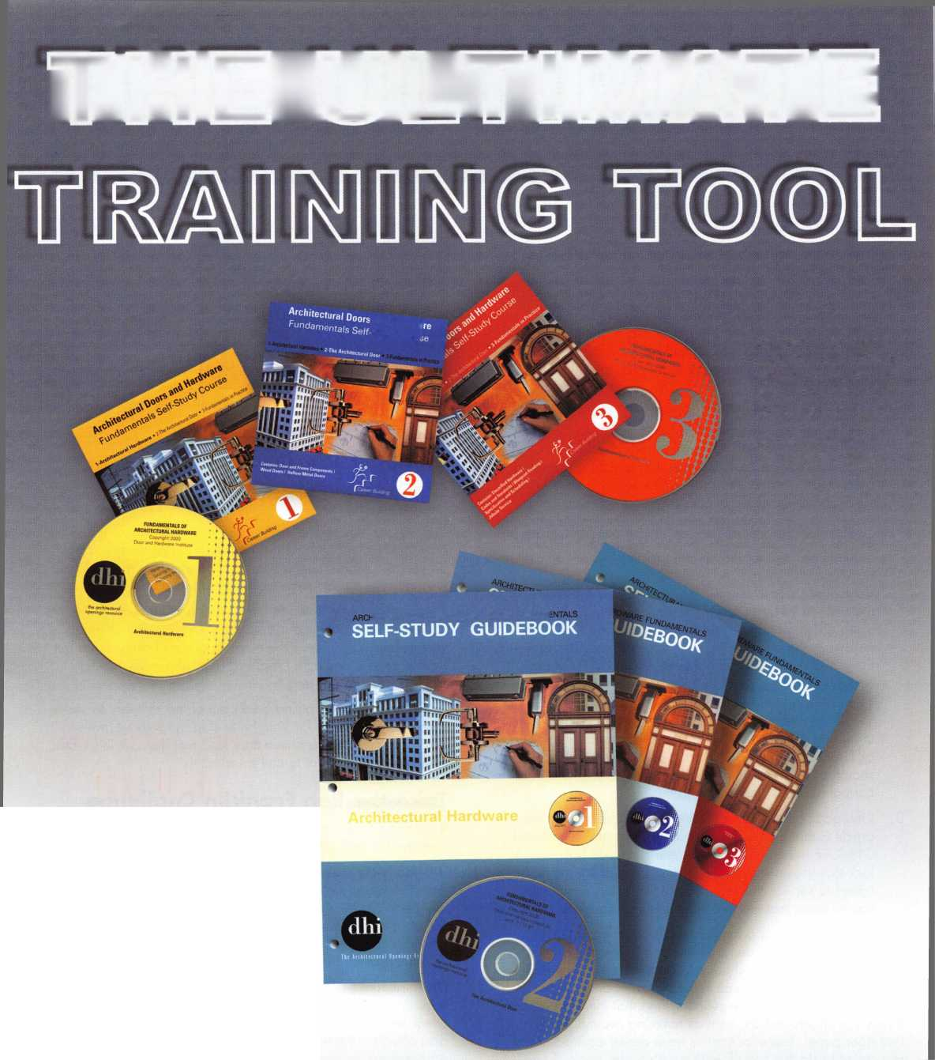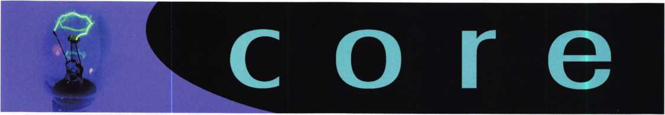

Viper Corrections

Corrections and additions to the Dodge Viper article, which appeared last month:

1. The key in photo 1 is NOT A TRANSPONDER KEY, and the Viper DOES NOT HAVE A TRANSPONDER SYS­TEM. Also, keep in mind that in photo 4, the light ring around the ignition bezel should not be confused with a transponder pick-up coil. We apologize for any confu­sion this caused.
2. The caption for Photo 1 8 is misleading. The word "door- lock" is not accurate (there are no driver or passenger doorlocks on this car); rather, the door is held by a latch, or cable-operated handle. The handle is operated by an electronic remote control. The receiving compo­nents of the electronic remote control are expensive and tricky to bypass. Although many of us are capable of getting into the panel and using a tool to open the door at the latch, it is not the opening method ALOA officially recommends. There is no need to put anything into the door panel, nor to remove the door panel. A better method would be opening the trunk by fitting a key using a determinator or an E-Z reader. If the battery is not dead, the alarm will go off. Once the trunk is open, there is a small opening between the top of the vehicle and the top of the seats (not big enough for an average­sized person to crawl through). A tool of some kind should be used to manipulate the emergency handle on the inside of the door. But unless it's an emergency or off-hours situation, don't bother; a vehicle this new should have a dealer key code readily available during normal business hours.
3. One additional note on the Viper not mentioned in the article is that the car has a small lock for the illuminated ON/OFF switch on the passenger's side air bag. It is a lock that uses a key, and it is possible that you could be called to service this lock. It's not likely, but we wanted you to know that this lock does exist on the Viper.

In closing, the Viper is a fun car, and from a locksmithing perspective, it is out of the ordinary and different; perhaps most of us won't get the chance to work on one of them. But, if one crosses your path, you should know (mainly) that you can fit a key to the ignition cylinder, and that there are some things you should not do, such as tinkering around inside that door panel. Some locksmiths have dealer contracts, and are called to do this sort of work on a regular basis. If you are one of these locksmiths, you probably don't need to heed ALOA's advice. But if you are not familiar with the Viper, fol­low the advice of the article's title: "Handle with care."

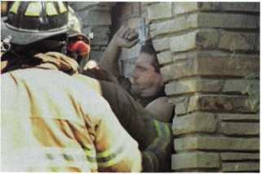

Locked-out Man Finds Chimney Too Tight

A Fort Worth man found out Tuesday that the chimney is not the way to get back in your house when you've locked your­self out.

Firefighters spent an hour tearing apart the chimney to free 35-year-old Mark Vaughn who said he was trying to help out his mother-in-law after she locked her keys inside.

"I was all the way down to the bottom and I thought I was OK because I could see it," he told KXAS-TV, with chimney soot covering his face. "There was a piece of rebar there but I got passed it and then I realized after about 30 minutes, call 911, I' m not moving."

Firefighters carefully pulled bricks out of the chimney to make a hole large enough for Vaughn to step out without any seri­ous injury. Vaughn said next time he would listen to his moth­er-in-law who told him to call a locksmith.

Take the Ben Franklin Challenge

If we can't save you money on your credit card processing, Ben Franklin will pay you $100.

Did you know that as a member of Associated Locksmiths of America you are eligible for discounted rates when accept­ing credit cards? ALOA and First National Merchant Solutions have developed a payment processing solution that provides competitive rates and opportunities to earn revenue with unparalleled customer service.

First National's program highlights include FREE online reporting, no monthly minimum processing requirements, check verification and guarantee solutions. First National also offers an Interest Bearing Account, which allows you to earn interest on your credit card deposits. Take the Ben Franklin Challenge! Call First National today, at 1-800-516- 6242 to take advantage of this special BTA promotion!

Note: Offer expires 12/31/02. Meet or Beat promotion is only available to members of ALOA. ALOA members are eli­gible for rates as low as 1.76%.

**8**

Keynotes • December 2002



Need Help?

At ALOA, we want to make sure you are getting as much  
bang for your membership dues buck as we are able to  
give you. If you have had problems getting membership  
services, or have a question regarding member services,  
please contact Bill Gibson, executive director, at 800/532-  
2562, or e-mail: [charlie@aloa.org](mailto:charlie@aloa.org).

New Certifications

CRLs

Neil Allen  
Yoshito Arai  
Uzuki Fumihiko  
Naohiro Futagami  
Jason Harris  
Timothy Horton  
Kinji Ichinose  
Chinaru Inaba  
William Lueke  
Kazuo Nishino  
Toshikazu Noborikawa  
Kohtaroh Ohta  
Clifford Shafer  
Dawn Smith  
Yoshio Suzuki  
Yoshiyuki Tanaka  
Eric Taylor  
Imamura Tsuneyuki  
Yuuko Uchimura  
Frank Ulbin  
James Wilson

CPLs

Mark Atkinson  
Dale Bowman

CPSs

Thomas Minnick

Let Us Know!

If you have an opinion to offer on ALOA, the state of  
the industry, or life in general, we want to know  
about it! Submissions to the "Mailbox" section of  
Keynotes are printed on a space-available basis.

Write to: "Letters to the Editor"; ALOA; 3003 Live  
Oak Street; Dallas, TX, 75240; FAX 214/827-1 810;  
e-mail: [editor@aloa.org](mailto:editor@aloa.org).

In Memory

Arthur Frost

Arthur Frost (ALOA Member #2093), 62, passed  
away in August. Art owned and operated A-1 Lock  
and Key Service in Clarksville, IN, from 1964 until  
1999, when he sold the business and retired. Over  
the years, Art held a number of leadership positions  
in the Louisville, KY, area, and in the Central States  
Locksmith Association. He was a member of Falls City  
Lodge No. 376 F&AM, and the Scottish Rite of  
Louisville. Art was a very kind, caring person, and he  
was also a highly professional locksmith and busi-  
nessman; his business associates, friends and family  
will miss him very much.

Kissimmee, FL Nagano City, Japan Shibuya-Ku, Tokyo, Japan Itabashi Ku, Japan Midlothian, VA Manassas, VA Koto, Japan

Machida City, Tokyo, Japan Lancaster, PA Shimizo City, Japan Okinawa, Japan Sagamihara Ka, Japan Cinnaminson, NJ La Fargeville, NY Itabashi Ku, Japan Edogawa Ku, Japan Liverpool, NY Edogawa Ku, Japan Tokyo, Japan Freehold, NJ Atlanta, GA

Mattydale, NY Salem, VA

Oklahoma City, OK

Lew Frank Noyes

Lew Frank Noyes, Jr., 76, a long-time  
ALOA member and an ALOA Board  
Member from 1988-1991, passed  
away on Nov. 3, 2002. Lew was  
born March 12, 1926, in Allegheny,  
PA. He moved to lake Worth in 1938.  
He was a U.S. Navy veteran of  
World War II. Lew worked for Martin-

Marietta for 10 years as a locksmith. He then worked for  
Pan Am as a safe specialist for 12 years before retiring.

He was known as the "Flying Locksmith" due to his exten-  
sive flying down range. He also worked for EG&G as a  
safe specialist, where he retired in 1995.

Lew was a founding member of the Central Florida  
Locksmith Association, a member of the DAV, life member  
of the Scottish Rites, a past master of Mt. Dora Masonic  
Lodge ANFM, Pan Am retirees, Locksmith Ledger Hall of  
Fame and SERLAC. He was also an early CML in ALOA.

In lieu of flowers, donations may be made to the American  
Cancer Society.

On behalf of everyone at ALOA, we would like to extend  
our deepest sympathies to the family and friends  
of Lew Noyes.

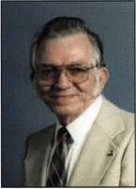

)fessiondi

Holds the Key to your

Savings'*

a lock on spending

Professional Business Products,

Associate ALOA Member, offers you  
lower prices, two color ALOA logo  
on standard forms and rebates to ALOA!

**For more information, visit us online: [www.professionalbusinessproducts.com](http://www.professionalbusinessproducts.com) or call 1-800-355-6322 for our catalog.**

(45X5*$) *Professional*

*Business*

*Products*

Keynotes • December 2002

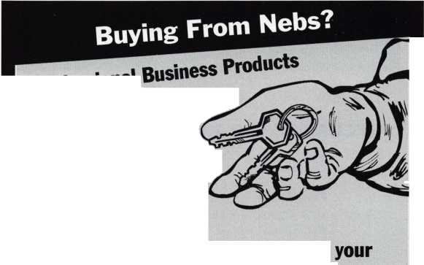

**FEB | JAN DEC**

**upcoming**

|  |  |  |
| --- | --- | --- |
| 4 Minnesota Chapter of ALOA | 7 ALOA & CLA Locksmiths | 7 Pacific Locksmith Association |
| First Annual Banquet | Holiday Celebration | "How To Make Money |
| Shorewood Restaurant ($25) | San Diego, CA | from Stolen Cars Without |
| Alan Morgan, Jr. | Dan Bozart 619-271-1155 | Stealing Them" Class |
| [alanmorgan@aol.com](mailto:alanmorgan@aol.com) |  | <http://www.pla-pro.org> |



14 GPLA Holiday Party 7-1 1pm Philadelphia, PA Robert Mock robertmock@comcast. net

**UPCOMING PRP SITTINGS**

|  |  |
| --- | --- |
| Dec. 8 | Allied Locksmiths of Youngstown Youngstown, OH  Tony Ramunno, CML, CPS  330-782-6204 |
| Dec. 13 | ALOA • Dallas, TX • Ashley Manson 800-532-2562, ext. 30 |
| Jan. 10 | ALOA • Dallas, TX • Ashley Manson 800-532-2562, ext. 30 |
| Feb. 14 | ALOA • Dallas, TX • Ashley Manson 800-532-2562, ext. 30 |
| Mar. 2 | Minnesota Chapter of ALOA Maplewood, MN  Dana Lee, CML* 612-968-4500 |
| Mar. 14 | ALOA • Dallas, TX • Ashley Manson 800-532-2562, ext. 30 |
| April 5 | MLANJ • Somerset, NJ • Dan McGlynn 973-267-8884 |
| April 6 | Clark Security Products • Chicago, IL Joan Emrick* 619-718-7308 |
| April 11 | ALOA • Dallas, TX • Ashley Manson 800-532-2562, ext. 30 |
| April 26 | Colorado Front Range Chapter of ALOA Denver, CO • Gordon Racine, CML 719-384-4707 |

May 9 ALOA • Dallas, TX • Ashley Manson 800-532-2562, ext. 30

June 13 ALOA • Dallas, TX • Ashley Manson 800-532-2562, ext. 30

June 22 Clark Security Products • Reno, NV Joan Emrick • 619-718-7308

July 11 ALOA • Dallas, TX • Ashley Manson 800-532-2562, ext. 30

August 8 ALOA • Dallas, TX • Ashley Manson 800-532-2562, ext. 30

Sept. 12 ALOA • Dallas, TX • Ashley Manson 800-532-2562, ext. 30

**UPCOMING ACE CLASSES**

Jan. 11 Wyoming Locksmiths Association

Casper, WY • Investigative Locksmithing I Gener Ficek, CPL • 605-642-4542

Feb.

22-23 Alabama Locksmiths Assn.

Basic Electricity and Intro to Access Control Amanda Floyd • 334-793-5060

Feb 28 -

Mar. 1 Minnesota Chapter of ALOA

Maplewood, MN • Dana Lee, CML 612-722-9181 •[Ill7@qwest.net](mailto:Ill7@qwest.net) Comprehensive 1C I & II (2 days)

Servicing Aluminum Storefront Doors Life Safety Codes and ADA

Mar. 3-7 Fox Valley Technical College • Appleton, Wl Jerry Antoon: 920-735-2406 [www.fvtc.edu](http://www.fvtc.edu) • See ad facing page

March

24-28 SAVTA (see ad inside back cover)

David Lowell, CML, CMST 800-532-2562 xl8

April 3-6 MLANJ • Somerset, NJ • Dan McGlynn 973-267-8884 • [www.mlanj.org](http://www.mlanj.org) 18 ACE Classes

April

24-26 Colorado Front Range • 9 Classes

719-384-4707 • [www.radisson.com/](http://www.radisson.com/) security educationweekend

May

17-18 Alabama Locksmiths Assoc

Birmingham, AL • Import Automotive I & II

July

14-18 ALOA 2003 (see ad page 1)

David Lowell, CML, CMST 800-532-2562 x!8

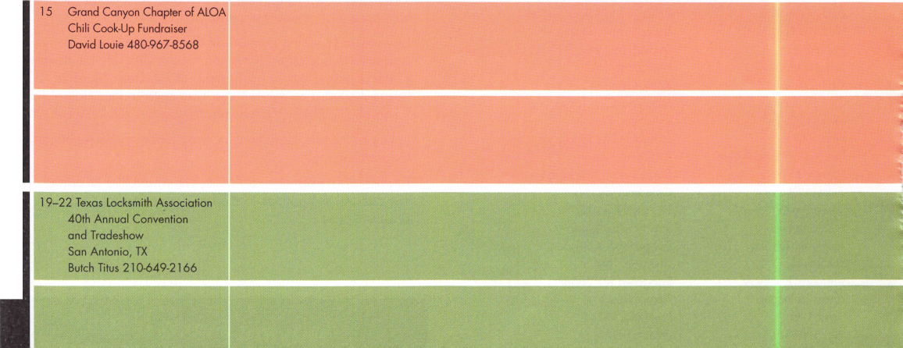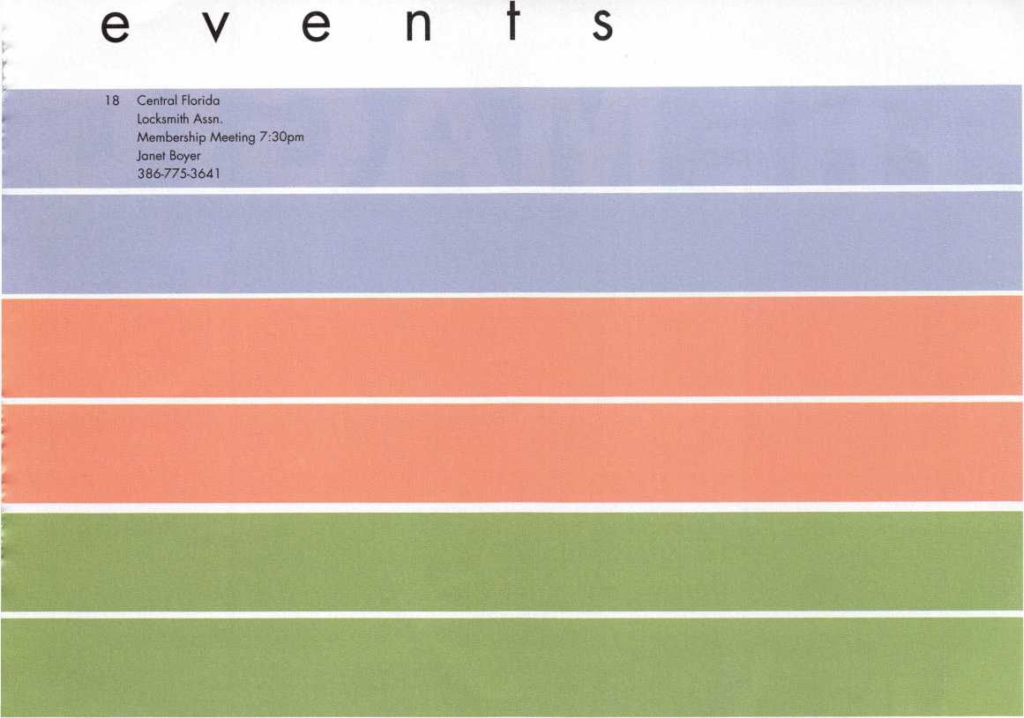

This is a basic locksmithing training course sponsored by FVTC’s Security and Crime Prevention  
Department and conducted by ALOA ACE instructors. Designed for the locksmith shop owner  
who would like to provide entry-level training for new apprentice locksmiths as well as those who

would like to receive professional training that will enable employment with a professional locksmith. The course will allow the student  
to gain enough knowledge to make them a starting apprentice in an existing shop. Job placement locations will be made available at the  
time of the class.

Locksmith Training

Sponsored by Fox Valley Technical College • 1825 N. Bluemound Dr. • Appleton, Wl 54912-2277

6-Day Program • Career Change in One Week • March 3-7, 2003

To maintain quality the course enrollment will be capped at 12 students. Enroll early!

Curriculum includes:

Key Blank Identification and Duplication Key Codes and Code Equipment Basic Master Keying

Lockset Servicing, Functions, Finishes

Life Safety Codes

Lock Pick Opening Techniques

Pin and Disc Cylinder Servicing Key Impressioning

Lock By-Pass Techniques Exit Flardware

Door Closers

Lockset Installation

Cabinet, Furniture, Mailbox Locks

All tools and equipment will be made available for use during training. Class Flours: 8:30 am to 5:00 pm every day Class Attire: Shop clothes Course Tuition: $995.00

Course Enrollment: See Susan Egnoski in the Criminal Justice Center

or call 920-831-4393

Note: Enrollment deadline is Friday, September 20, 2002



By Paul F. Chandler CRL

Our story begins in 1880 when the Curie brothers discovered an interesting  
phenomenon occurring in certain natural crystals. This occurrence came to be  
known as “The Piezoelectric Effect,” which described the Curie brothers’

discovery: that applying a force to these crystals resulted

in an electric field building up. Ever since this discovery,  
engineers have exploited this property developing  
switches that use the direct piezoelectric

effect to transform a dynamic mechanical  
stress into an electric signal. That low  
power signal can be used to acti-

vate a solid-state switching cir-  
cuit, opening or closing a higher  
power circuit.



By contrast, ordinary switches are electromechanical in nature. Applying pressure to the switch actuator moves electrically conductive contacts together or apart, allow­ing or preventing electric current from passing through the switch. Because there are moving parts, there is inevitably wear and tear.

Especially vulnerable are the switch contacts

that actually make and break the electrical cir- i

cuit. Arcing occurs when the contacts are X *''■

close together, but not actually touching. i - ' I

**a. ***--'*•**

This results in burning and pitting of the

contact surface, leading to higher igF'm

resistance and eventual switch fail- ^ ^

ure. Another challenge with ^ ^

mechanical pushbuttons is A

keeping moisture and dust

out of the electronics. r B

Keynotes • December 2002



Piezo switches are constructed by attaching the  
piezoelectric material to the back of a metallic mem  
brane. Pushing the membrane results in  
no discernable movement. And yet,

pressure applied to the front of the  
membrane is converted into a small  
electric current that is used to switch a  
secondary circuit. Piezo switches con-  
structed this way have no moving parts,  
no arcing and no openings that invite  
wetness and dust.

Secura Key offers a line of access con-  
trol keypads that use piezo technology.  
Built of a single piece of aluminum, the  
surface membrane is o.6mm thick. The  
entire keypad is filled with a rubbery  
potting compound that seals the unit  
completely against environmental con-  
ditions. Ten digits (0-9) plus a “#” and  
“*” symbol are anodized into the alu-  
minum and will never wear off. These  
units are suitable for temperatures  
from -40 00F to +25700F and for humid-  
ity up to 100% (actually, they even  
work when submerged). Tested in  
excess of 50 million cycles, these key-  
pads meet Mil Specs 202E, 810C, 461B  
and 462 as well as IP68.

SK-KPM and SK-KPS are Wiegand-output  
keypads for use with a separate access con-  
trol unit such as the Secura Key SK-ACP.  
The digital code entered at the keypad is

**c**

00

SB

transmitted, along with a facility code, to an access  
control panel in a conventional 26-bit format.

Digital keypads are often used where the  
convenience of a PIN (Personal

Identification Number) is more important  
than the higher security of an access card.  
Keypads can also be combined with card  
readers to ensure that the person present-  
ing the card is an authorized cardholder.

B

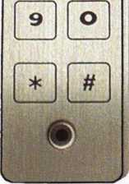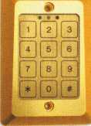

KPM-SA, KPS-SA, KPF-SA and KPI-SA  
are single-door, standalone access control  
units for up to 200 users. Completely pro-  
grammable from the keypad, these units  
are ideal for many traffic control and mod-  
erate security applications. Their rugged  
construction makes them especially well  
suited to outdoor use. User codes can be  
4 to 8 digits long, with 100- million possi-  
ble combinations.

KPM-SA is a narrow (2 button by 6 but-  
ton) surface mounted keypad. SKF-SA  
is also narrow, but designed for mortise  
installation. KPS-SA is a switchplate  
style keypad (3 button X 4 button),  
designed to cover a single-gang box.  
KPI-SA is an illuminated, brass finish  
switchplate style keypad.

So, the next time you see something that  
looks like a block of aluminum with numbers  
on it, give it a press. It may look and feel as  
though nothing is happening, but inside,

piezoelectricity is working its magic. Q



Keynotes • December 2002



The LCN

Auto-Equalizer

By Dave Thielen, CML

I recently had the opportunity to install a new low-ener­gy door operator. After some consideration, I chose the LCN Auto-Equalizer for its features and benefits.

The Auto-Equalizer Model 4820 is a non-handed, non- sized, low-energy door operator. One unique feature is that the 4820 is pneumatically operated. This makes installation very easy, as a control box with air pump, timers, circuit board, etc. are mounted separately from the actual door closer. A small pneumatic tube connects the control box to the door closer. The Auto-Equalizer will work manually like any door closer or automatically upon activation of one of a variety of switches. One of the other benefits of a pneumatic door operator is it can come in either a concealed or surface mounted version. Other benefits include its quiet, efficient control, no high voltage wiring on the door frame, and ease of instal­lation and maintenance. And since the control box and closer are separate, it is easy to troubleshoot, or replace a component without replacing the entire unit.

Let’s start our installation. Before beginning, I removed the old door closer. Next I checked the operation of the door and made any repairs or adjustments as needed.

The 4820 installs like any standard door closer. I installed the 4820 to the top jamb with six screws using the supplied template [photoi]. Two screws are used to install the shoe to the door. The main arm is installed and connected to the rod and shoe. At this time, you can check the closer operation, and make any mechanical adjustments like any other door closer, using a hex wrench to adjust the valves. Adjustments include main speed, latch speed and backcheck. Closing force can be adjusted by turning the spring adjustment nut on the end of the closer. Photo 2 shows the pneumatic tubing con­nected to the end of the closer. Photo 3 shows a roll of

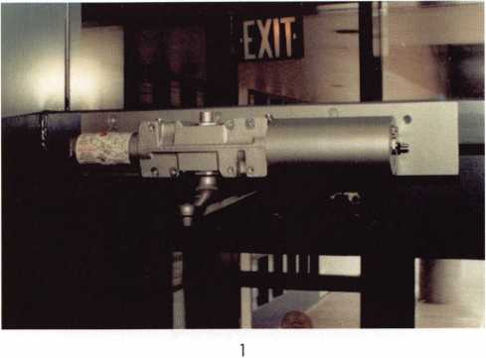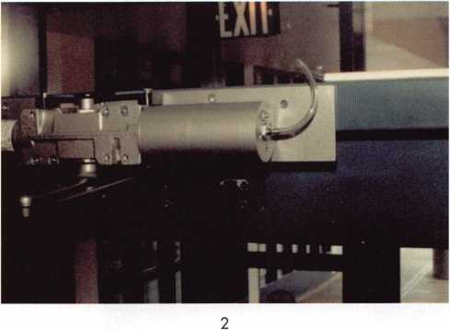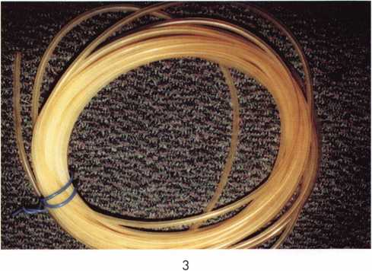

Keynotes • December 2002

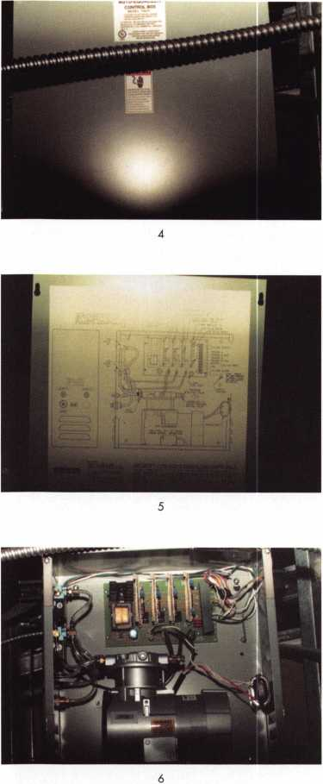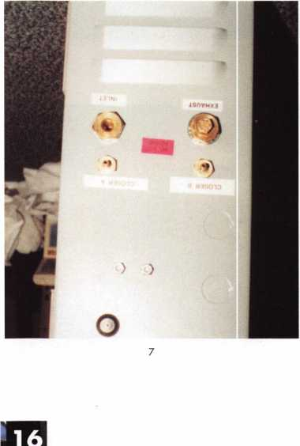

925 tubing. Do not try to substitute tubing, as the 925 tubing is specifically made for the Auto-Equalizer.

The hardest part of this job is routing the 1/4 inch tubing to the control box. If possible, I try to conceal the tub­ing in the door frame. An ideal spot to mount the con­trol box is above the door in the ceiling. This is a con­venient location, and makes routing the tubing rather easy. Wire mold (or some similar material) can be used to surface the tubing if there is no other choice. The 7982 control box should be installed no more than 25 feet from the door closer for peak performance. Photo 4 shows the control box mounted in the ceiling. To do a professional job, I fastened the box to a piece of ply­wood that was covered with acoustical tile to reduce any noise or vibration. Next, I screwed the plywood to the studs in the suspended ceiling. Photo 5 shows the cover of the box removed and the wiring schematic. This is a handy reference when installing the unit, or doing any adjustments later. Photo 6 is the inside of the control box. It is shipped to you already assembled, with the pre­liminary wiring connected. The air pump can be seen at the bottom; at the top is the timer boards and terminal block. At the left is the tubing that connects to the air valves. Photo 7 shows the side of the box. This is where the tubing presses on to the fitting. This control box had two fittings (Closer A and Closer B) to handle two doors sequentially in a vestibule. Photo 8 shows a close-up of the circuit board. At this point, I had electricians run 120 Volt AC power into the box, hooking up the red wire to #3 {line} and white wire to #4{neutral}. There is also a green wire connected to the ground screw. This was all I needed from the electricians. The rest is low voltage 12V DC outputs.

I chose to use the RF, wireless switches to activate the Auto-Equalizer. In existing buildings, it would be very difficult and a great expense to run wire underground and outside to the wall switch. The wireless switches are very easy to install and use a small transmitter and receiver similar to a garage door opener. Photo 9 shows the 931 RF receiver on top of the control box. Photo 10 shows the RF receiver tucked inside the control box to

Keynotes • December 2002

protect it from dust, etc. The  
RF receiver is connected to  
terminals 8,9, and 10.

All I have left to do is install  
the switches. LCN refers to  
them as 957 RF actuators.

Photo 11 shows the actuator.

Use a small screwdriver to  
snap off the side trim pieces  
to expose the mounting holes  
and inner compartment.

Photo 12 shows the inner com-  
partment with 9-Volt battery  
and circuit board. The two  
plug in leads connect to the  
outer pushbutton seen in  
Photo 13. For a single door  
application, mount one actua-  
tor inside near the door, and  
one outside near the door at a  
height of 36 inches. Be sure  
the dip switches in the actua-  
tor match the receiver. Make  
any mechanical speed adjust-  
ments at the closer. Make any

door open time delay adjustments at the timer cards  
contained in the control box.

To complete the job, install a decal on each side of the door, [photo 14}. Many options are available such as a sequential door opener, multiple door opener, a selection of hardwired switches, wireless, scanners and handheld transmitters, as well as relays to inte­grate with electric strikes, card readers, etc.

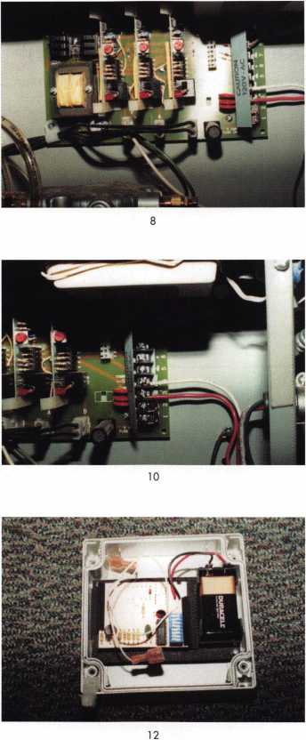

9

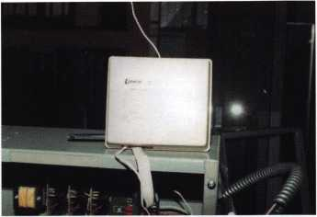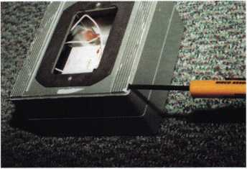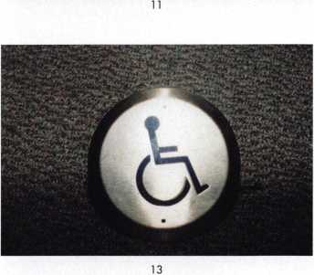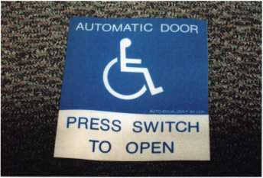

I would recommend a yearly service contract to the customer. Once a year, you could return and make any needed adjustments, but more importantly, change the 9 Volt battery in the actuator, as you know they never think of it until the battery is dead. I found the LCN Auto-Equalizer very reliable, sim­ple to install, low maintenance and a very versatile low energy door operator. Q

Keynotes • December 2002

BOARD

nominations

**What ALOA Board Positions Are Open and Where Am I Qualified to Run?**

There are currently seven regional directors positions open for election in addition to the position of President. ALOA members now elect the directors from their own regions. Only ALOA members from a region are eligible to run for the open posi- tion(s) in that region. And only mem­bers from the nominees region will receive a ballot to vote for that can­didate. Members from any region are eligible to run for the President position. You must have been an ALOA member for at least three years to run.

The following vacancies will exist for the election to be held before the ALOA 2003 Convention.

**President**

**Southeast two directors**

**North Central two directors**

**Southwest two directors**

If you have any questions, please contact Charles Gibson at (800) 532-2562 or email [charlie@aloa.org](mailto:charlie@aloa.org).

On this page you will find the required nomination petition and on the following page, the nomination form.

The following is the number of signatures required for each Board position:

**President 25**

**Southeast 11**

**North Central 13**

**Southwest 12**

Associated Locksmiths of America, Inc.

Board of Directors Nomination Petition

Please print legibly or type. This form can be reproduced if needed.

I, the undersigned, request that be placed on

(name of nominee and member number)

the ballot for for the election to be held at

(position for which individual is being nominated)

the special meeting of ALOA members to be held in 2003 or any adjournment thereof. I am eligible to vote in the region.



PRINTED NAME



PRINTED NAME



PRINTED NAME



PRINTED NAME



PRINTED NAME



PRINTED NAME



PRINTED NAME



PRINTED NAME



PRINTED NAME



PRINTED NAME

11

PRINTED NAME

12

PRINTED NAME



PRINTED NAME



PRINTED NAME



PRINTED NAME



PRINTED NAME



PRINTED NAME



PRINTED NAME



PRINTED NAME



PRINTED NAME

21

PRINTED NAME

22

PRINTED NAME



PRINTED NAME



PRINTED NAME



MEMBER #

MEMBER #

MEMBER #

MEMBER #

MEMBER #

MEMBER #

MEMBER #

MEMBER #

MEMBER #

MEMBER #

MEMBER #

MEMBER #

MEMBER #

MEMBER #

MEMBER #

MEMBER #

MEMBER #

MEMBER #

MEMBER #

MEMBER #

MEMBER #

MEMBER #

MEMBER #

MEMBER #

SIGNATURE

SIGNATURE

SIGNATURE

SIGNATURE

SIGNATURE

SIGNATURE

SIGNATURE

SIGNATURE

SIGNATURE

SIGNATURE

SIGNATURE

SIGNATURE

SIGNATURE

SIGNATURE

SIGNATURE

SIGNATURE

SIGNATURE

SIGNATURE

SIGNATURE

SIGNATURE

SIGNATURE

SIGNATURE

SIGNATURE

SIGNATURE

PRINTED NAME

MEMBER #

SIGNATURE

YOUR COMMITMENT TO ALOA BOARD SERVICE

(Please read carefully and sign where indicated.)

The responsibilities of an ALOA board member include contributing a moderate amount of personal time, and a significant degree of professional guidance and expertise to the organization.

You will be expected to come to board meetings and the annual membership meeting. You will need to be prepared to sensibly discuss matters of great importance to your profession and participate in setting policy as part of a governing body. Your course of action during your tenure on the ALOA board should be guided by fair minded, constructive goals pertaining to matters of consequence for ALOA and for the industry. Your contributions are expected to benefit ALOA as a whole, taking individual member rights and concerns into account, but free of the taint of partisan politics or personal gain.

On a practical note: ALOA board members are expected to behave and dress professionally at all times, especially when actively representing the association. ALOA board members are required to participate in two board meetings per year, of three or four days in length, one each fall and spring. Board members are also asked to attend the annual con­vention and are required to attend the annual membership meeting. Board members may also be asked on a voluntary basis, to represent ALOA at related local, state or regional functions, including serving in the ALOA Booth and otherwise promoting ALOA. When travel is required for a board member, expenses covered by ALOA include lodging, travel and a reasonable **per diem.** The Board has stipulated that assigned travel will be reimbursed at the lesser of the 30-day advance tourist class airfare in effect at the time of travel or the current per-mile rate for travel by personal automobile. Spouse expenses, including extra room charges, etc., are the individual's responsibility.

• • •

I have read and understand the above responsibilities of an ALOA board member, and agree to commit my time and energies as needed. I certify all of the information contained on this form and supporting documentation to be true and complete.

I can be contacted with questions at:

Address Phone #

Signed: Date

Please attach a recent photograph of yourself and retain a copy of this profile for your own files. This profile and all supporting documentation should be submitted no later than March 1, 2003:

Mail to:

Nominee Profile

Secretary of the Board of Directors  
Associated Locksmiths of America, Inc.

3003 Live Oak Street  
Dallas, TX 75204-6186  
1-800-532-2562

Locked Open?

Customer Blunder Brings Us Inside the Cencon ATM Electronic Lock

By Greg Perry, CML, CPS

Sometimes customers do dumb things all by themselves;  
other times they need some coaxing. This was the case with  
some “new” ATMs at a local credit union. Two NCR Class 5890  
model oioi’s had been installed for their new drive-up islands.

These are double door units with Mas-

Hamilton Cencons on the cash dispens-  
ing side and LaGard 3332 mechanical  
locks on the deposit side. The reason for  
the double door set up is to allow credit  
union employees to retrieve deposits  
without having to open the side with all  
the money. The money side is loaded by an  
armed guard service. Robbers are “supposed”  
to know how this works and only show up  
for the big money when the armed guard  
service is loading, not when the credit

union employees are unloading the  
deposits. The credit union called

Brinks (the armed guard service) to  
have them load the ATMs with cash.

Brinks asked them to spin the dials  
left until they powered up. They were  
then told to press the number 2 to  
find out the serial number of each  
unit. Until they are first programmed,  
the factory combination is 50-25-50.  
Spinning the dial will lock the units  
that, until this time, have been open

with the dials taped to prevent anyone from spinning them.

Have you guessed what happened when they tried the factory  
combination? They’ve already been programmed for some other  
institution. Unfortunately, the supplier doesn’t remember for  
whom they were programmed. At this point, one door is locked

**mi m**

Keynotes • December 2002

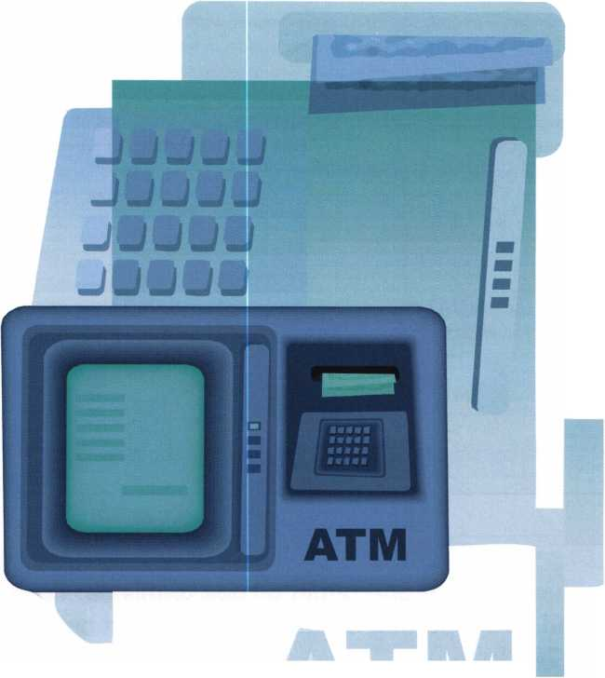

open and the other  
locked shut.

The ATM supplier  
called me in a little  
panic; could I go out  
and swap locks on the  
open unit, drill the  
locked up unit, repair  
it and replace the lock?  
We discussed pricing  
and agreed before I  
went out. I received

the locks two days later and proceeded to the job site.  
I started with the open unit first. This allowed me to  
see the inside of the unit and get familiar with lock  
handing and verify the lock vintage or style. Mas-  
Hamilton has made two different versions of this  
lock. The first or older style uses a stepper motor like  
the X-07 lock. The newer style has a solenoid with  
spring-loaded slide that pulls the lever into the drive  
cam. The serial number, according to Joe Cortie (for-  
merly of Mas-Hamilton) will give you the lock style.

If the serial number starts with a “1,” it’s a solenoid  
style; if it starts with any other number, it’s a stepper  
motor style lock. Finding the serial number is accom-

plished by power-  
ing the lock and  
pressing “#2,”  
exactly as the  
armed guard serv-  
ice had asked the  
credit union

employees to do. The lock will display “Sn” followed by three two-digit numbers for a six-digit serial num­ber. These locks were both stepper motor style locks. The locks have an extension attached to them that controls a lock bolt position switch. The stepper motor bolts were drilled and tapped for an 8-32 screw; the solenoid locks were drilled and tapped for 10-32 screws; this is not a major problem provided you have 10-32 flat head screws with you. After swapping the lock on the first unit, taking pictures and measure­ments, I moved to the second locked up unit.

I checked the serial number to make sure the lock was also a stepper motor style lock. The standard four-screw dial puller included in the StrongArm Mini-Rig kit will not work on this lock, because the keypad and display are sticking out from the dial ring preventing access to two of the screws. The first option is to grab the dial knob securely with a pair of large vise grips and rock it off. This method worked on this lock. If it hadn’t worked, an alternative is to drill down the center of the dial and remove the spin­dle shaft to below the setscrews that hold the hub to the spindle. Once the dial is removed, the screws holding the dial ring cover can be removed. This allows access to remove the cable and finally the dial ring mounting plate, leaving a bare door with the spindle and cable sticking out. I checked the lock already removed against an X-07 lock body to confirm the lever tit location is identical. This allowed me to use the StrongArm template or base plate number four, drilling at location “Q”. This is 13/16” over or left and 13/16” toward the bolt. The solenoid lock uses a

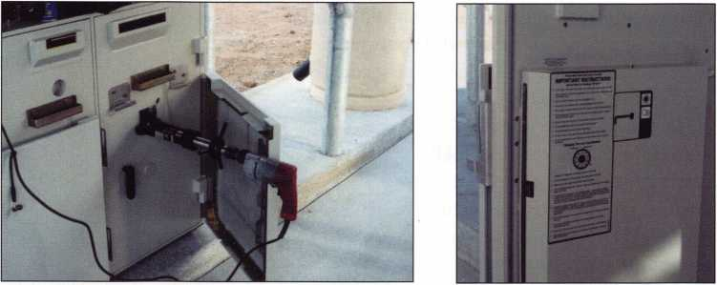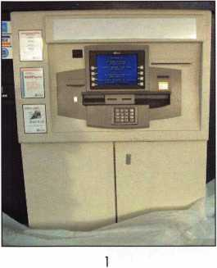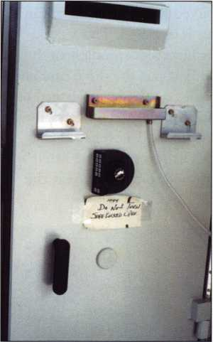

2

Actual door caption reads,  
"Do Not Turn Safe Locked Open"

3

After the dial and ring are removed,  
the Mini Rig is attached to drill the hole.

Both doors have the same back cover  
and single-plate bolt

Keynotes • December 2002

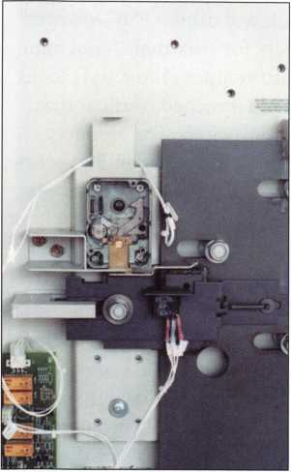

5

Old-style lock with the hole below and  
right of the lever. The other location to  
drill is for the lever screw.

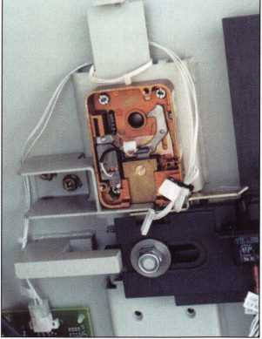

6

This is the solenoid-style lock.  
Notice the lever is slightly different.

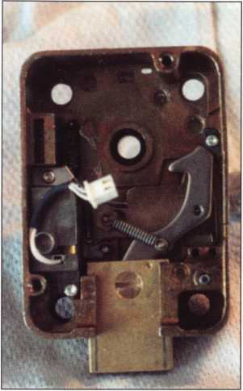

7

This is the solenoid-style lock  
with the bolt extended

slightly different location; Joe Cortie suggests using a  
measurement of 3/4” x 3/4” for both when using a 1/4”  
bit. This will overlap the hole enough to catch both  
styles. The 3/8” thick hardplate on these units is  
respectable. It took three StrongArm carbide bits to  
get through to the lock case. Switch back to a high-  
speed steel bit to go through the soft case then back  
to carbide or a cobalt bit to drill the stainless steel tit  
off. The object is to drill the tit off but not through  
the whole lever. This will allow you to probe the lever  
into the drive cam while turning the spindle to retract  
the bolt.

Once the door was open, the lock was removed and a  
carbide pin was welded from both sides in the hole.  
The weld was ground flush and spot putty was applied  
to restore the surface. I used a spray can of GSA

parchment color paint. It’s  
close, but far from a perfect  
match. Installing the new lock  
is straightforward — just fol-  
low the instructions, use care  
routing the cable and wear a  
grounding strap to prevent  
static discharge from damag-  
ing the lock.

I will point out two areas that could cause trouble: first, the bolt is shipped retracted. If you must extend the bolt, use the key or probe (it’s taped to the back cover) to reset it. The solenoid style lock uses a cross- locked relock. The relock is reset by inserting the key into a hole on the side of the lock case, snagging the “spring” inside and pulling the relock out. This will allow the bolt to be retracted holding the relock in place until the back cover is installed. The second problem that may arise is incorrect spindle length. This is because when you first put the drive cam and spindle into the lock, it rides on the lever instead of bottoming out against the lock case. (Don’t ask how I figured this out, but remember, I never read the instructions first, either.) The lever must be lifted slightly and the spindle turned to properly seat the

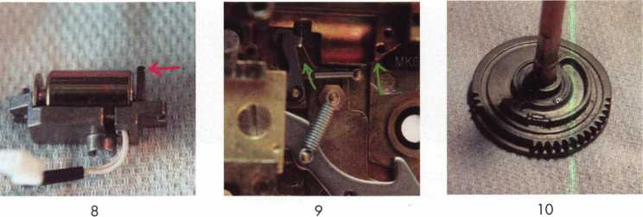

Solenoid assemply removed.  
The hook connects the release  
lever in photo 9 9

NSO's Dave McOmie  
suggests an alternate drilling  
at the other end of the solenoid  
and then pushing in the button.

Old-style drive cam

**22**

Keynotes • December 2002

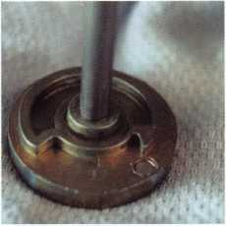

11

New-style drive cam

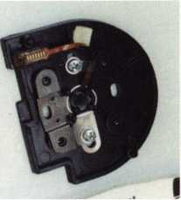

12

Dial ring base plate

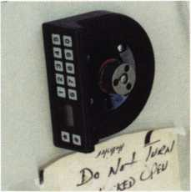

13

Dial ring and hub installed. Test the lock before installing dial.

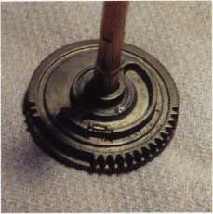

14

Back cover is installed.  
The lock reset key is  
under the tape

drive cam. If you don’t do this, the spindle will be about i/8” longer then it should be. Once the spindle is cut, the dial hub and back cover can be installed. Test the lock before installing the dial, just in case you’ve cut the spindle too long or other adjustments need to be made.

A few more notes regarding this door. The door is prepared for a second lock to be installed vertical up if the customer should request it. The spindle hole is plugged with a through bolt. It has no relock relying only on the internal relock trigger in the lock to pre­vent or thwart a punching attack. The door has some electronics installed for alarm functions. Considering the amount of money some ATMs hold, it amazes me how little physical protection is built into them. Cencon locks are probably only going to be found on ATMs. If you are familiar with the Mas-Hamilton line, they will offer few surprises. Q



**SAFE CORPORATION**

MANUFACTURES OF QUALITY DEPOSITORY SAFES AND CHESTS

DISTRIBUTING FROM WAREHOUSES IN

* LOS ANGLES, CA
* CHICAGO; IL
* GLASSBORO, NJ

A & B is now a stocking distributor

for Mutual Safes

featuring

AB-4-30-3S AB-9-2 WS 10-2

Chose from over 75 models in stock

We ship your order within

24 hours

See us

*ot [www.a-bsofecorp.com](http://www.a-bsofecorp.com)*800-253-1267  
Fax 856-863-1208

CALL FOR YOUR  
CATALOG TODAY

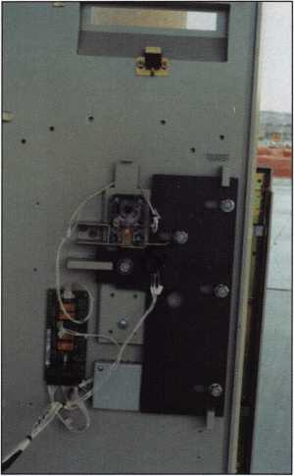

15

A pull-back shot with the second  
lock mounting location seen below  
the primary lock.

Keynotes • December 2002

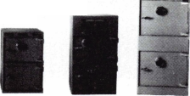

Keynotes • December 2002

Part i

By Sal Dulcamara, CML

If you didn’t know anything about CyberLock from Videx, photograph i would just appear to be a picture of an ordinary assortment of mechanical locks and/or lock cylinders. By tipping the lock cylinders with the keyway opening exposed, photograph 2 illustrates something out of the ordinary There is not much typical about these lock cylinders, and the key that operates them (just below the lock cylinders) is hardly typical, either. What you are seeing is a relatively new and very unique concept in lock hardware technology. The CyberLock system is mainly an electronic access control product, but it is unlike anything else you have seen before.

Photograph 3 shows an ordinary padlock with an extraordinary lock cylinder inside it, and an extraordi­nary electronic key to its right. The keyway opening for this lock cylinder is the same as the four lock cylinders shown in photograph 2. You have a slightly closer view in this picture. The tip end of the elec­tronic CyberKey mirrors that physical profile. There are electrical contacts in each for transferring data back and forth from one to the other.

CyberLock is electromechanical access control. While the key is essentially electronic, the CyberLock cylin­der has electronic components, but actuates the lock­ing mechanism (in which it is contained) mechanically. What you currently know as electronic access control

is generally limited to certain applications. There is a very wide variety of lock brands that make electron­ic locks intended for use in standard entry doors. Most electronic lock/access control systems must work together within an exclusively mated lockset. The CyberLock system is essentially self-contained within a lock cylinder and (as a consequence) can go virtually anywhere.

One of the virtues and great selling points of elec­tronic access control (in contrast to strictly mechani­cal locks of the past) is the ability to provide locks that limit access to individuals by day and time. An ordinary mechanical lock has keys that work all the time. Unless you were to rekey the lock every evening and switch it back in the morning, the key of an employee that works 9 to 5 will work any other time of the day-even in the middle of the night. Many brands and models of electronic locks can have keys that not only limit access to certain times of the day, but also prevent use on weekends and holidays. Mechanical locks and keys can’t compete there.

These locks also have distinct advantages over strictly mechanical locks in the area of master keying. Individual keys can be made to open a rather complex assortment of door locks without creating the nega­tive security compromises found in master keyed mechanical locks. Also, access to individual locks can

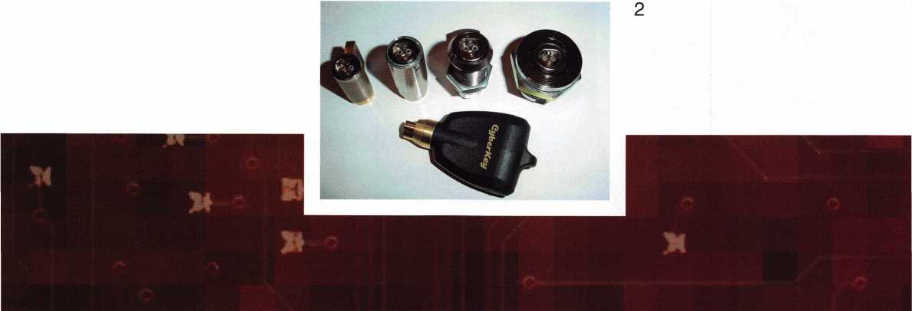

Keynotes • December 2002

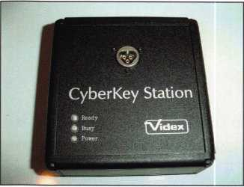

be removed  
without affect-  
ing other key  
holders. This  
means old keys  
don’t necessari-  
ly have to be  
retrieved, and  
new keys don’t  
have to be  
issued.

There is one final advantage of (many) electronic locks that I want to mention. They can be audited.

If an employee returns to work at 2 a.m. and enters the building, a mechanical lock will not reveal the entry An electronic lock can not only identify whose key was used in the lock, but what day and time also. Now, the benefits I have ascribed to electronic locks applies to more than just the Videx CyberLock. On most entry doors, CyberLocks can be just effective as any other electronic locks. The significant distinction is that there are things and places other than standard entry doors where this type of security could prove effective. Outside of Videx, there are few other prac­tical options.

Consider the possible circumstances and situations where a customer might want or need the capabilities of electronic security, but that a device designed (pri­

marily) for an entry door would be out of the ques-  
tion. How about cabinets or drawers that contain  
controlled substances such as found in a hospital or  
pharmacy? How about just about any type of com-  
partment or container that your customer wants to  
keep anything of importance or value securely stored?  
In most of such cases, the container or device couldn’t  
use a lock any larger than your typical small cam lock.  
How many electronic locksets do you know of that  
would work in those circumstances? Well, Videx hap-  
pens to make a CyberLock cam lock that is no larger  
than a strictly mechanical cam lock. The CyberLock  
version, however, does all the things that you would  
normally find on a large and cumbersome electronic  
entry door lock — a lock that you wouldn’t even  
consider attempting to install on a small cabinet.

The same applies to virtually every other locking  
application where an entry door lock would be out  
of the question, but where some kind of rather small  
mechanical lock is currently installed. A CyberLock  
can go virtually anywhere any small mechanical lock  
cylinder can go.

Although a CyberLock cylinder is electromechanical,  
there are parts of the CyberLock system that are  
exclusively electronic. Photograph 4 shows the pro-  
gramming manual (with program disk slipped inside),  
a CyberKey Station and a programming key. The pro-  
gramming will have to originate in your computer in

conjunction with the CyberKey  
Station. The CyberKey Station is  
essentially a programming link  
between your computer and a pro-  
gramming key that will be required to  
communicate with any CyberLocks.  
The programming keys will contain all  
data provided by the computer to be

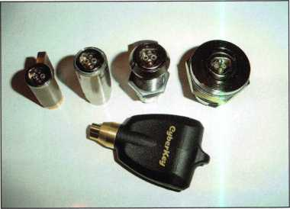

4

5



Keynotes • December 2002

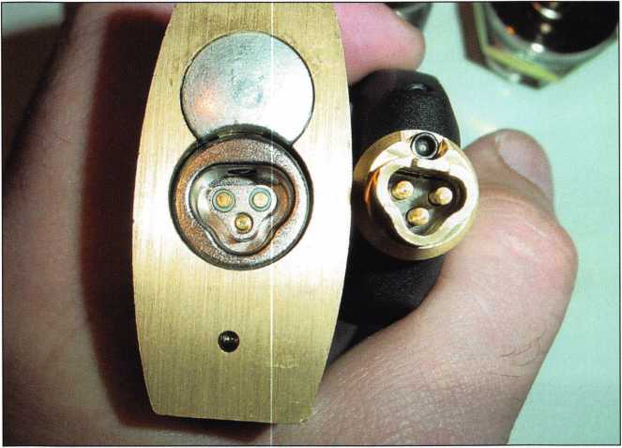

sent to the locks or audit data drawn from the locks to go back to the computer.

A closer view of the CyberKey station can be seen in photograph 5. You should recognize the same profile found as the keyway opening of any of the CyberLocks shown earlier. When the programming key is inserted there, it could either upload program­ming data from the computer to program the individ­ual CyberLocks in the system, or it could be used to download audit data previously obtained from an indi­vidual CyberLock.

Photograph 6 shows a CyberLock programming key and two different versions of a CyberKey. The one at the right, with the plastic handle is more typical, but a metal-encased version (shown in the middle) is also available. All the keys are larger than a typical mechanical key because they contain electronic com­ponents and a battery. The size of the key may be one of the very few down sides to the CyberLock system.

Photograph 7 shows a vending type lock about to be opened with a CyberKey Vending machines are one place where traditional electronic access control prod­ucts are not typically suited, but would be an ideal application (and very possible with CyberLock). The key inserts not unlike a tubular lock key does. An LED flashes as the electrical contacts of the key and lock connect. If the key is authorized, as in photo­graph 8, the key will turn and unlock the lock. If not authorized, it won’t.

The CyberLock is able to be so compact because the electrical power source is in the key rather than in the lock. The actual restriction of access is in the key

moreso than in the lock. The key decides what day or time that access is allowed and the key also contains the clock and calendar. There is one other very interesting thing that the CyberLock system does that most other electronic locks don’t. Opening attempts are stored both in the key and in the lock, so the lock can be audited for every key that made contact with it and the key can be audited for every lock it tried to open.

I had indicated earlier that the CyberKey Station was used for downloading or uploading information to programming keys. Well, regular CyberKeys are programmed through it and can be audited through it, also. Right now, I have told you about the very basics of CyberLock operation. Between now and next month, I will tell you about how I put the CyberLock through its paces and next issue, I will provide a fully detailed explanation of operation and programming. Q

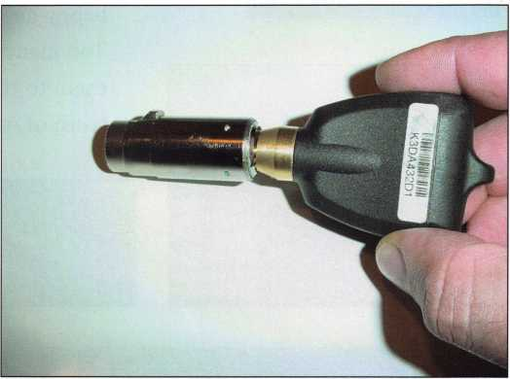

8

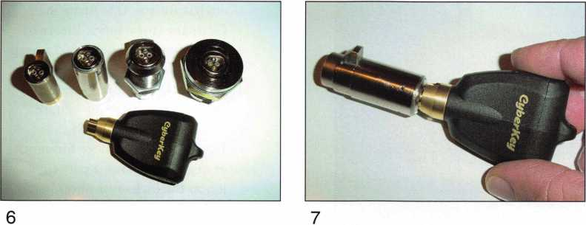

Keynotes • December 2002

**2**

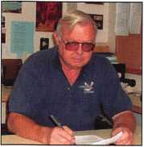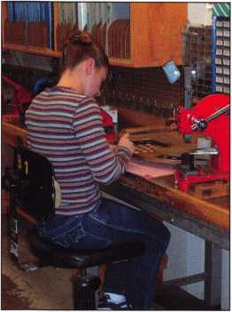

2 Miles High:

Institutional Locksmithing at Northern Arizona University

The truth is that we at Keynotes learned about Chuck Snelling, CML, of Northern Arizona University long ago, and frankly, his legend was a little hard to believe. It’s not that we’re a skeptical lot here at Keynotes, but how do you get a sharp image of a guy who learned locksmithing back in the 1950s as a boy scout, and from there, eventually made his way some 7,000 snowy feet above sea level to beat the drum of institu­tional locksmithing to all who’ll listen? You know, snow in Arizona? Come on — he sounded more a Bigfoot myth than the concerned,

happy-go-lucky locksmith scholar we eventually tracked down.

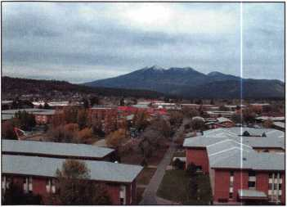

Too many before us had let their fear of the unknown blind them to the reality of institutional locksmithing. Here’s the truth of what we found when we hunted down Bigfoot:

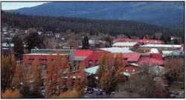

Keynotes: Hi, Chuck. Thanks for talking

with us.

Chuck: No problem.

Keynotes: First we’d like to know how you

got into locksmithing, and what has the profession come to mean to you as a person?

Chuck: I learned how locks work and

how to pick locks in my scout troop and junior high school (1952-1954). While an intelligence analyst for the U.S. Army in Germany (1959-1963), I learned more about, and practiced surrep­titious entry. After my service in the Army, I went to college and worked some years in welfare and social work. In 1981,

I came back to college for anoth­er degree and took a part time job in the locksmith shop here at Northern Arizona University. I’m still here. I enjoy the chal­lenges that go with the job.

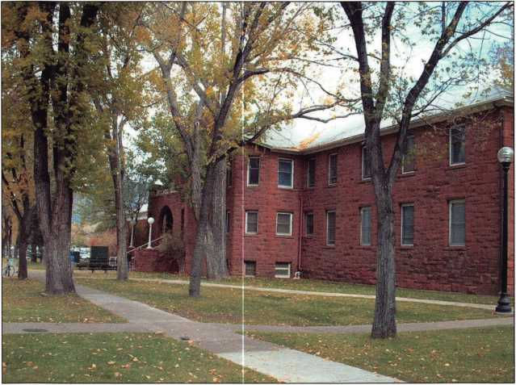

Keynotes • December 2002

Keynotes: Tell us about how you became an institutional

locksmith.

Chuck: I started as an intuitional locksmith here at

NAU and as a member of the Arizona Army National Guard, assigned to Navajo Army Depot for one weekend a month and my two weeks of active duty each year (1983-1996).

Keynotes: What’s the best/worst part about being an

institutional locksmith at NAU?

Chuck: This university is a great place to work. Our

shop has complete control of all locks, doors, door hardware, automatic doors and access control in use on campus. We all enjoy the challenges of providing security for 20 resi­dence halls (dorms), major research facilities such as our anthrax lab, and a very large and busy campus. The staff, facility and students are great people to work with. The only bad part is dealing with state budgets in years like this one and the related bureaucratic problems that go with any job in a large institution.

Keynotes: What’s your favorite tool or equipment that is

specific to Institutional locksmithing? Why?

Chuck: I’m not sure we use any tools or equipment

that are different from commercial locksmiths who install and service the same kinds of hard­ware we use.

Keynotes: Tell us about NAU.

Chuck: Our total enrollment is 19,907 students this

fall. About 14,000 of those are here on our main campus and the rest attend classes through interactive TV classrooms located in 26 statewide sites. We have 100 buildings here on a little more than 300 acres of the main campus with 4.5 million square feet of floor space. We have about 75,000 locks on campus. Northern Arizona University began as Northern Arizona Normal School in 1899, and our door hardware still represents many of the decades since 1899. We use Best interchange­able cores and keys. Our current hardware standards include Best locks, Precision Hardware exits, LCN closers and Horton and LCN automatic entrances, OMNI and Trilogy stand-alone, and a variety of hardwired elec­tronic access control systems. Our lockshop staff includes myself, three other full time locksmiths (one is also a carpenter and door specialist) and eight part-time student work­

ers. Our student crew is currently upgrading the stairwells on campus to the current fire code (a multi-year project).

Keynotes: Tell us about the ILA, your chapter in

Arizona, and why you’ve taken a leadership role with them.

Chuck: I became the locksmith supervisor here at

NAU in 1985 and my goal was to improve the professional qualifications of the shop staff.

In order to establish a professional education program, we started bringing in factory people with all the latest training. To make it worth­while for these companies to come all the way to Flagstaff to put on their classes, we would invite other northern Arizona institutional locksmiths from federal, state and local gov­ernment agencies, reservations, school dis­tricts and hospitals to come join us for the training two or three times a year. We weren’t really organized, but 30 or 40 of us would get together to have fun and learn something new. Because some of our members travel almost 200 miles to get here, we have limited our training to two or three days a year. Our train­ing has included Best, Falcon, Schlage/Primus, Sargent & Greenleaf, Precision Hardware, Detex, Alarm Lock, AMSEC/Star, LCN, Locknetics, Simplex, Markar hinges, extrau- dart doors, and a number of locksmith classes taught by the NAU lockshop staff. Our staff specialties include handicapped access solu­tions, fire and life safety codes (including fire rated assemblies and safe and vault work).

The ILA was a group of intuitional lock­smiths, so we affiliated ourselves with them. Our group really isn’t a traditional chapter.

We meet as scheduled on Thursdays, two or three times a year, for a full day of professional training and helping each other.

Keynotes: Tell us your favorite institutional locksmithing

story (maybe your toughest job at NAU, or a specific time in your career that changed the way you thought about your profession).

Chuck: I plan to retire in the next few years and one

of my projects is to write a book about being a university locksmith. I like college students (I used to be one) and the most interesting challenges come from service calls in residence halls. You’ll have to wait for the book to hear my favorite stories, but be assured they will all be true and it will be a big book!



Keynotes • December 2002

Whatever we do, especially when we are responsible for the safety and security of others, it’s important to be a professional.

Keynotes: Is there something specific about life in

Arizona that makes institutional locksmithing different or challenging?

Chuck: When people hear the word “Arizona,”

they think of heat, cactus and sand.

The NAU campus is located in northern Arizona at 7,000 feet above sea level. We get an average of 100 inches of snow in the winter. We are surrounded by old and some not-so-old volcanoes. So, in addition to weather extremes, we have volcanic cinder dust which is a very abrasive material. The cinder dust increases wear on everything from car tires to locks and cylinders. We have become specialists in the maintenance and lubrication of precision mechanical devices in an extreme and abrasive environment.

Keynotes: What responsibility do you feel as a leader

among today’s institutional locksmiths? What’s your advice to them?

Chuck: Twenty some years ago, a friend in the door

hardware business gave me some very good advice, and I’ll pass it on again. Whatever we do, especially when we are responsible for the safety and security of others, it’s important to be a professional. Every job should be profes­sional, every customer contact should build professional confidence, and then, back up your work with professional credentials.

The PRP can be an important part of that, so is participation in training and, especially, association with other professionals.

Keynotes: How can ALOA work with I LA to help insti­

tutional locksmiths (maybe the PRP?)

Chuck: ALOA needs to recognize institutional lock­

smiths as locksmiths. We work in a highly spe­cialized field of locksmithing and many would have a lot to learn in order to be successful as

commercial locksmiths. The same applies to commercial locksmiths coming into an institu­tional job; many of them would also have a lot to learn. In the last 20 years, I have heard the same thing over and over. “University lock­smith? Are you a real locksmith?” In 1986,

I had a national officer of ALOA tell me that the PRP wasn’t really designed for people like me because of our limited knowledge and experience! So every time the tests came to Arizona, I would go take as many as I could.

It took two years, and cost $200 for travel and testing, to get my CML. I was actually follow­ing the advice of the friend mentioned above. Just about everyone at this university has something behind their name; PhD, EDD, MBA and you know the rest of the story.

We have vice presidents, assistant and associate vice presidents, provosts, assistant provosts, deans, directors, chairs and depart­ment heads like only a university can. I know most of these men and women and they are professionals and some of the top people in their fields of study. They also know me as a professional and one of the top people in my field of study.

Keynotes: Thanks for your time, Chuck. We appreciate

you sitting down and talking with us.

Chuck: My pleasure.

Editor’s Note: The PRP and its focus have come a long way since its inception in 1985. Since then, institutional lock­smiths have served on the ALOA board of directors and have been members of the PRP committee. The institu­tional locksmiths are a valuable part of the locksmith industry, and ALOA has made a commitment to them, as can be seen through our regular monthly articles on institu­tional locksmithing, and in the educational programs spe­cific to institutional locksmithing that are scheduled throughout the year. Q

**30**

Keynotes • December 2002

**Renew or Apply for Membership ONLINE at [www.aloa.org](http://www.aloa.org)**

**During times of crisis, unity is key. Right now, when you join ALOA  
(or renew your membership), you will receive, free of charge,  
this patriotic decal for your shop or van, which serves as a  
special reminder to you and your customers that it takes  
a spirited effort to strengthen the ties that bind us.**

**HLUH Locksmiths** m

Secure America

**Decal dimensions 8'/2" x 57V**

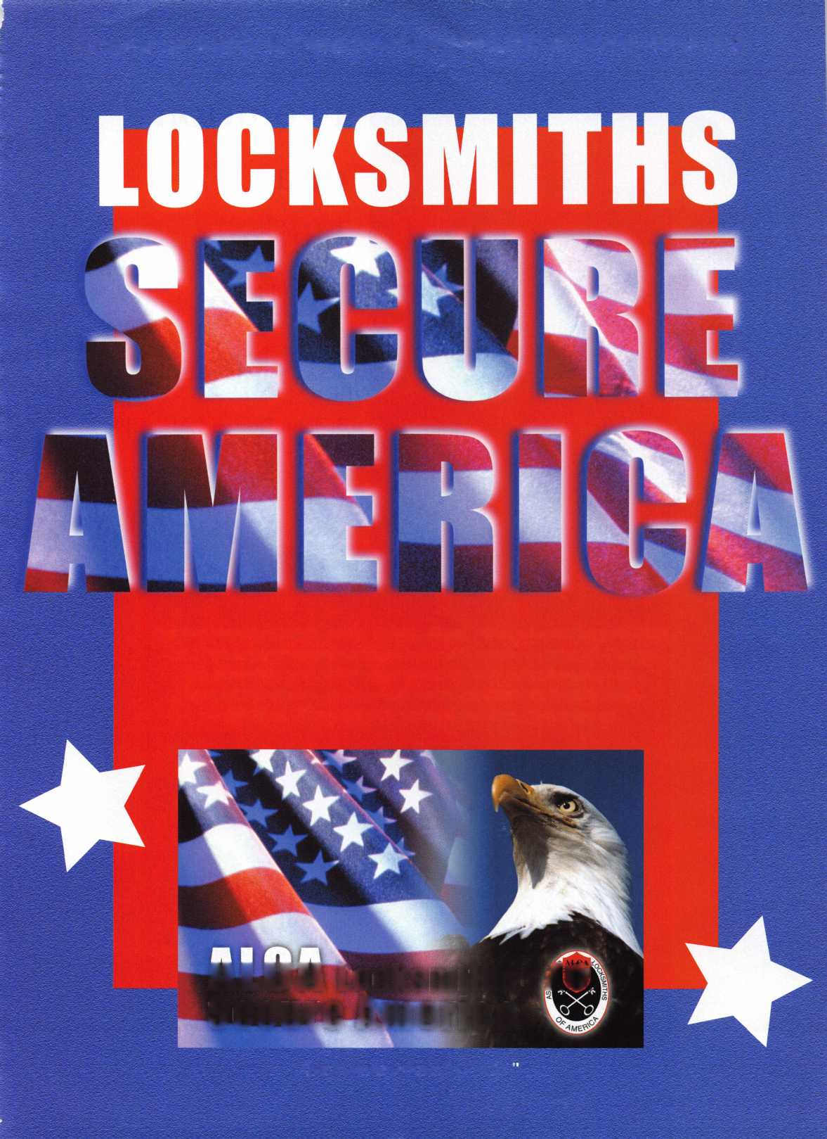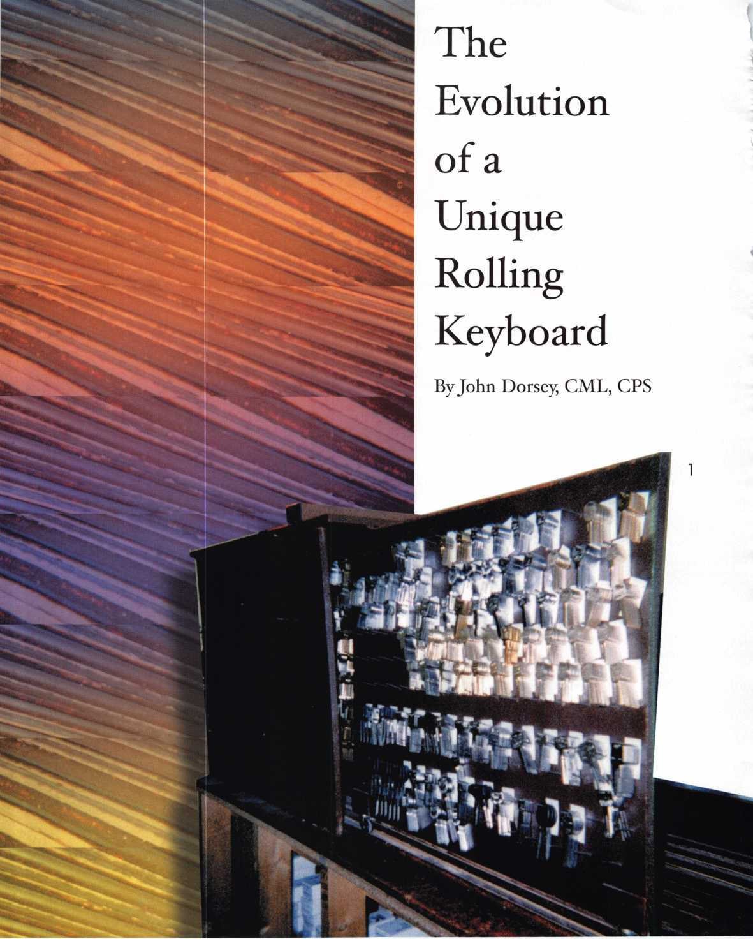

Keynotes • December 2002

When customers see a neat and clean appearing place as they enter a lock and key shop, they get a good first impression. A good first impression is a def­inite bonus for our customers and a plus for us shop owners as well. A neat, organized atmosphere gives customers a nice warm, fuzzy feeling.

By the nature of our profession, locksmiths are required to have thousands of key blanks readily avail­able for quick duplication. That display of keys all to often takes up a very large percentage of the wall space in most lock and key shops. While a very sys­tematic display of tens of thousands of key blanks may be self-satisfying to the shop owner, a point of pride, as a matter of fact, it can look somewhat unat­tractive to the public, and even keep you from dis­playing other, more important things on your wall space. But what the heck? It’s the nature of our busi­ness, and we gotta do what we gotta do, right?

Not necessarily

lifted vertically, placed into a notch at an angle, and then the board provides access to a multitude of key blanks on that particular board. A fabulous concept, one that works incredibly well.

When I see a good, workable concept for something, and I think it over, have a few ideas or changes that would make the application of the original idea work better for me, then it is time to put those ideas into something tangible.

Since, at the time, I was strictly mobile, I needed access to a very large number of key blanks, far more than any such metal box could provide. So I studied the basic idea and converted it to a horizontal appli­cation of the same concept. I cut eight boards from 1/4-inch particle board, with nails as pegs for the blanks. The boards would slide in and out of a box guided by tracks on both the top and bottom of the box. It worked very well. The sliding key blank boards moved with a reasonable amount of effort, but stayed

Over 20 years ago, I was strictly mobile. I had a Dodge “KaryVan.” The cube van had the cab of a standard van with a big box behind the driver’s seat. It was high enough for me to stand up inside. Those types of mobile shop vehicles are still popular with many locksmiths today.

There was, and I believe there still is, an excellent product designed especially for mobile shops. It is a strong metal box with a cushion top to be used as a seat in the working area of a mobile shop. Inside the strong metal box are several key boards that can be

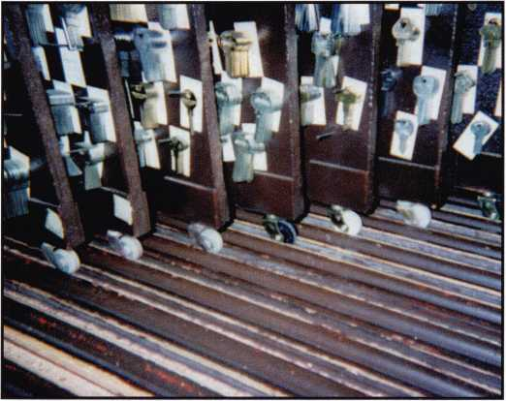

2



3

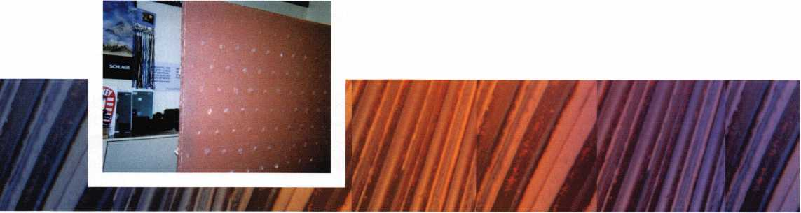

Keynotes • December 2002

put with the bumps, turns, and stop-and-go driving. Blanks bouncing off the pegs was not a problem; it did happen, but not to a serious degree.

When I opened my storefront shop in 1981,1 wanted the same format for a key blank board, that I had in my mobile shop. But since I was no longer exposing my keyboards to the bumps, turning pressures, nor the forces of stop-and-go driving, I no longer needed the friction of the sliding boards.

What I did need was keyboards that could be easily moved in and out of a new key box. Necessity was my mother of invention. The comparable key box and rolling boards that I designed had caster wheels that were guided in much wider tracks that would make the moving in and out of the box far easier. The fin­ished box consisted of 12 pieces of 3/8-inch particle board, each measuring 32”X24”. The bottom corners had to be reinforced to keep the casters securely in place; the 3/8” particle board was a little too thin for the casters (see photos 1 and 3).

Each board had approximately 150-165 six-penny finishing nails for pegs. That fit my needs for total capacity. Yet, each nail broke through the back of the particle board, even if only slightly (see photo 2). That, in effect, reduced the capacity of each peg and made an unattractive back of each board that the public would see every time I pulled one out. I recog­nized the shortcomings, but function was accom­plished, even though aesthetics fell short. The six­penny nails also had heads a little too large for the hole in the bow of some blanks, so I occasionally had to take out my 6-inch flat file and make the offending nailhead smaller.

Each existing board weighed 70 or 80 pounds, fully loaded, and the casters were rated at 25 pounds each (with two casters, there was only a 50-pound capacity per board). Of course, back when I bought the mate­rials for the boards, the manufacturer of the casters gave size only, and no designed weight suggestion.

The capacity of the old key box was approximately 29,000 blanks if each peg was filled with GM ignition and secondary type blanks. I know there are a lot of much larger and thicker blanks, but for maximum capacity figuring, that is the measure I used. Just to satisfy my own curiosity, at one point, I made the effort t count how many keys were actually hanging on all the boards. There were over 21,000!

I made a point of not filling each board to its capaci­ty; I always left at least one or two, sometimes more pegs vacant in each row for future expansion. There are always new automotive and motorcycle blanks, as well as new blanks for domestic and imported resi­dential knobsets. It seems the lock manufacturers just love to make us buy new blanks.

I used and tried the true format of pegboard spacing (i.e., pegs two inches apart and staggered every other row, with two inches between rows). My planning for the original boards was not as good as it could have been; I left far too much space from the top of the boards to the first rows. That made for wasted space and lower capacity (see photo 1).

For the ease of my future employees, many of whom I expected would likely have no experience in lock- smithing and key duplicating, I organized the keys by Curtis numbers (now commonly called “EZ”), arranged alphabetically, instead of the more confusing Ilco numbers.

The first board had what I called the “Hardware Store” selection, most of the fast movers likely to be found at any hardware store key location. The second board held the domestic auto key blanks. The next three boards were import automobile and motorcycle blanks, again arranged alphabetically by auto or motorcycle brand name. Then came the more com­plete selection, beginning with Abus, Ace, Arrow, and so on, including a nearly complete array of sectionals for Corbin, Sargent, Schlage, Russwin and Yale. The last board was for Safe Deposit blanks and bit keys. Most pegs had do-it-yourself key tags with prices and blank numbers for ordering.

Besides the economical use of space, it freed up my wall space for the display of retail accessories, signs, and even some hanging plants. My walls did not look like a typical lock and key show, by any means.

Over the years, I received many compliments on my rolling key board box. Even many locksmith friends have made mention of the simplicity of the design and the basic idea.

As time and wear took their toll on the original cast­ers, many were replaced on an individual need basis. About a year or so ago, the manufacturer of casters made an “improvement”: the casters were made a cou­ple of thousandths wider. That forced me to widen



Keynotes • December 2002

the bottom tracks slightly to remove the binding that the wider wheels caused. It was not only difficult and time consuming, but also not a precision job. I am a good locksmith, but not a very good cabinet repairman.

It was 21 years ago when I opened my storefront shop. Age and 21 years of use took their toll, and my old reliable key box, with rolling boards, was dying!

It became painfully obvious that it had to go. It was not an easy decision; I loved my rolling key board box. Yet, I knew that improvements and many changes would have to be incorporated into its replacement.

Plans started forming in my mind. Ideas for doing it better, making it stronger, more attractive. Details and photos of the new and improved “Rolling Key Board” will appear in part two, next month. Photos 4 and 5 show my “Old Reliable” in its last days. Oh the memories. Q

5

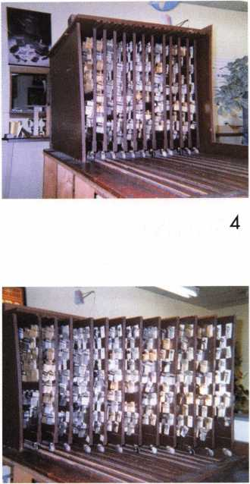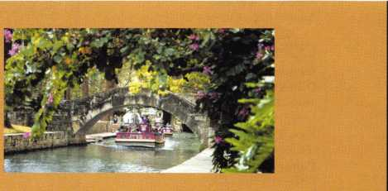

**Party**

**Las Vegas Style**

**Casino Party**

**Saturday, February 22. 2003  
7:30 PM - Midnight**

**Win Great Prizes!  
Indulge in Exotic Foods!**

**GRAND PRIZE...**

**A 5-day cruise for 2 on  
Celebration/Carnival  
Cruise Lines**

For Registration Information  
Contact: Butch Titus, TLA Secretary  
210-649-2166 • [btitus@sprintmail.com](mailto:btitus@sprintmail.com)  
or

1-877-TLA-INFO

[www.texaslocksmiths.org](http://www.texaslocksmiths.org)

Get Ready to Cruise!

TLA Annual Convention and Trade Show  
Wednesday, February 19-Sunday, February 23. 2003  
San Antonio, Texas

Hawhorn Suites Hotel and Municipal Auditorium

* Classes • Party
* Clinics • Officer
* Seminars Elections
* Exhibits

TLA announces a special

event you won’t want to miss!



Keynotes • December 2002

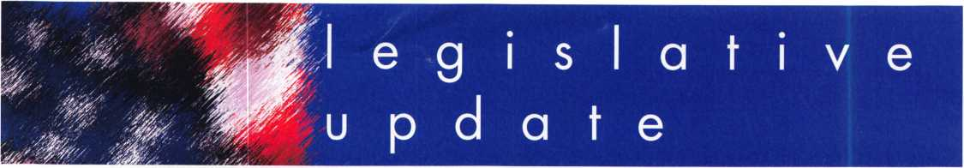

RECORD NUMBER OF ALOA MEMBERS JOIN THE LEGISLATIVE ACTION NETWORK

ARE YOU ONE OF THEM YET???

Over 550 members from 44 states, Washington DC, Puerto Rico, Army Europe and six countries currently partake in ALOA's Legislative Action Network (LAN). LAN members are our best resources at the grassroots level for effecting legislative change. They monitor each state legislature for bills affecting the locksmithing profession, including related industries. They organize media contact which helps the public understand our profession. Members contact state legislators; organize letter writing campaigns; and keep everyone informed in state and regional locksmith associations. Members assist the national ALOA office with state fundraising campaigns in situations where our profession is faced with detrimental legislation and a lobbyist is deemed necessary to assure success.

Members in bold type donated to the legislative fund this year, and members in italicized type gave generously by donating $100 or more during the 2002 legislative session and are members of the Legislative Action Network Council. To join, simply email Director of Public Policy, Tim McMullen at [tim@aloa.org](mailto:tim@aloa.org) for a pledge card.

ALABAMA

C L. Wiggins CPL Charles Farkas Jr Dallas C. Brooks David G. Rosengarten Dennis D. McLeod James D. Turner Jr, CML John P. Luhrs CRL Keith R. Lewis CML Lloyd E. Willits CRL Paul A. Przyborski Roger G. Williams RL Steve H. Sills William C. Singleton

ALASKA

Scott L. Henke, CPL, CPS

ARIZONA

Joe Pielech CRL, CPS

Lester J. Frederick

Nicholas A. Monaco CRL Robert A. Arthur RL William Lee CRL

ARKANSAS

Arthur R. Paholke RL

George Brumley RL George Freeman Randy L. Marler CRL Ronnie R. Hisaw

CALIFORNIA

Adam Weinraub

Arthur E. Patch CML **Autley Musselwhite Bruce** 5. **Nemec CML** Bryan Nicholas CML

Bryian Hill

Channing W. Tucker CPL

ALOA LEGISLATIVE ACTION NETWORK MEMBERS (as of October 1, 2002)

Charles E. Skobrak Sr, RL

Dale E. Barry

Daniel S. Enriquez CRL David L. Stevens

Dennis C. Halliburton **Donald L. Brown CML**

Earl Halls

Ellen S. Johnston

Elyse D. Rothstein Frank D. Hartung CML Fred L. Chiappe Gary L. Blanchard

George E. Phipps RL Gregory L. Perry CML, CPS

Jay E. Long Jeffrey S. Bowers

Jesse J. Hassell RL

John H. Cosby CPL

John H. Linn

Jon Rickard

Judee G. Silver

Julie McCluney CRL

Ken Robison

Marion J. Walters CRL

Neil A. Harding

Neil A. Jehning CRL, CPS

Norman Weisenburger

Paul C. Taormina RL

Paul F. Chandler CRL

Peter C. Carey

Ralph O. Skytte

Robert C. Slama

Roy W. Stinson

Shane E. Huff

Sharon L. Roper

Timothy Braun

Tom M. Wirth

Ui Kwang Kim

Wayne A. Sanderson

Wayne M. Carrington

Wilbur E. Jeffrey

Wilbur O. Mann CRL

COLORADO

Dean I. Carpenter

Gordon R. Racine CML

Richard L. Dyer CRL Thomas R. Gonzales

CONNECTICUT

Gerald G. Roraback Gilbert N. Wade CRL John J. Walsh

Lester H. Harris Mark S. Wistrand CRL Michael D. Sigmund Peggy L. Hobbs Phillip H. Hobbs CPL Richard A. Labbe Robert A. Gabris Jr Robert H. Stafford, CML Ward L. Kaye

DISTRICT OF COLUMBIA

Ernest Twyman

FLORIDA

Arthur M. Shoob Jr, CML **Barbara J. Hogan**

Brad R. Volpe Bruce M. Ratner

**Claude A, Hensley** Curtis W. Himelright CRL Dana L. Johnson CML Fernando Alvarez Frank G. Haucke Gary L. Cooper Glenn J. Carrigan **Grant** H. **Grein CRL** Howard B. Jolowsky Irving Isicoff James R. Barnhardt RL Janet W. Boyer CRL Jeffrey M. Gater CPL, CPS

John E. Cawby

John E. Jackson RL **John R. Presti Sr** Juan F. Pujol

Ken Kupferman CRL Kenneth J. Weiner

Kent M. McFarland CRL

Mel Roseman Michael J. Sullivan Michael W. Dorn

Nicholas W. Flieger

Norbert King RL Patrick M. Gatward

Richard Moller

Robert G. Reid CRL

Robert J. Morrissette CML, CPS

Rolando Bouza

Terrance L. Rix

Thomas W. Tate CRL Tom W. Olson Van R. Schneider CRL

William C. Groover

GEORGIA

Irving M. Smoot James L. Lester Jr **Joe Earley** John T. Grist CML

Joseph H. Peek Larry C. Cook CRL

Maurice W. Hatfield RL

Michael D. Robinson CRL Michael T. Day CPL Patricia R. Barrett Robert C. Gilmer CRL

HAWAII

Herman Salz CPL

IDAHO

Carvel G. O'Dell

Keynotes • December 2002

Kerry J. Hansen Steven D. Gilseth

ILLINOIS

Alexis L. Boisvert

Anne M. Gruber

Arthur T. Pankhurst

Barry M. Shaw CML Bill J. Robertson CML

Carlos U. Lopez Charles E. Carlson Daniel L. Schafer Donald E. Brown

Eugene Gyure

Eugene R. Anderson RL, CPP, AHC

Frank A. Schlesser Gary L. Connor CRL Gary L. Goffinett

Gerry J. Griffin

James E. Gruber CRL

Jim D. Harnden CRL

John J. Greenan CML, CPS

John W. Murphy CRL

Joseph W. Stevens CML

Judson B. Saas CPL Kathy A. Zaniolo CPL Keith R. Fisher CRL Kevin E. Ahrens CRL Larry E. Smith CPL Lawrence I. Barrett Jr Lawrence I. Barrett Sr, RL Lee E. Schreiber Michael Donigian Michael Fallon Perry M. Stillwell Phillip M. Witkovsky Sr.

Richard A. Holliday Richard J. Crnich Steven A. Wade Sylvester Jones Jr, RL William G. Forgas William H. Pulley CRL

INDIANA

Cynthia M. Scheuer David P. Snyder Sr Dean E. Robinson Gary P. Zuchowski RL James G. Tinder John W. Erney Jonathan C. Wursthorn Lucian L. Hayden Ralph J. Gaw RL

IOWA

David M. Howdle Donald G. Sharp CML Kenneth R. Novey CRL

Marlin R. Pearson CPL Philip J. Heath Sharon J. Bradford

KANSAS

Brenton K. Sloan CRL Dana R. Hall

Daniel M. Graffeo CRL, CMS Denver R. Oliver Doug G. Ackerman

Elvis D. Hammerschmidt CPL

Jeremy Friesen

John P. Campbell CRL

Michael R. Graves

Volker H. Von Hillebrandt

KENTUCKY

B. W. Cook

Donald L. Gardner Gilbert G. Herbig CPL Lewis Taylor

Michael H. Gambill CRL Thomas B. McKinney

LOUISIANA

Carl M. Braun Jr James L. Queen CML John A. Morovich Mark A. Queen Randall R. Jones CRL Rodney P. Blanchard CRL

MAINE

David P. Hallee CPL

MARYLAND

Carl L. Hedges CRL

Eric Roes CRL

Eric H. Wilderson

James W. Mullins CPL

John A. Speakes

Joseph M. Mooney

Lance A. Edwards

Lester S. Brodsky

Michael E. Stang CML

Michael W. Tingler CML

Paul I. Strock

Philip A. Rovenolt CPL

Raymond P. Grueninger

Richard C. Shellhorn CML, CPS

Richard S. Boyd

Robert D. DeWeese CML

Wallace W. Campbell Sr

Walter N. Ussery

William V. Breazeale CML, CPS

MASSACHUSETTS

**Barry** McMen/mon Carl L. Feinberg CML

Daniel J. Rackliffe CML

David H. Preston Denise A. Feinberg CML

George D. Condon III

Henry A. Fusari

Irwin M. Alfred Jack Hobin CPL

John H. Perron RL Joseph T. DePrimo

Nancy S. Corbett CRL

Paul Agostino **Paul A. Wesoly RL** Randall P. Benoit

Stephen L. McKinney William J. LaBarge

MICHIGAN

Frank W. Tellerico

James J. Austin CRL James J. Belcher Jesse Kippola **Jimmy** L **Movrry CML John H. Williamson CRL** John K. Hubei CML Joseph A. Morelli CRL **Kenneth A. Griffin** CML, **CPS** Lewis L. Barber **Mark E. Blum CML, CPS** Mattheu L. Monroe CRL Michael R. Schleyer CPL Ralph M. Dembeck

Richard D. Dozier Salvatore J. Dulcamaro CML Thomas J. Pelosojr, CML

Todd A. Phillips

MINNESOTA

A Lowell Torkelson CRL

Cory L. Schmidt

David A. Paulsrud Sr, CML

George W. Thomas RL Glen D. Polyard Jerry A. Longer Michael Childs

Michael J. Foty CPL

Michael R. Hauge

Michael S. Karch CPL, CPP Paul M. Justen Paula L. Hall CPL

Scott H. Wilmore

MISSISSIPPI

Bruce J. Tarbet CML, CPS Donald E. Rule CML

James W. Green CRL Leo E. Pahlke Jr Ronald G. Ferrill

MISSOURI

Alan B. Clark Sr, CRL

Bob Bever CRL

Bruce R. Becker Charles W. Sherrell RL

Doug K. Martin CRL Edward A. Hite CML

Harold M. Franken RL

James A. Ayers Sr

James E. Baxter

Jeanne B. Hendricks Jill E. Rich

Lawrence E. Dickhans

Mark Weaver Randy Mize Richard A. Miller CPL

Scott M. Guetschow William J. Forrester CRL

MONTANA

Eugene L. Cote'

James J. Morrissey

James M. Watt CML, CPS

NEBRASKA

Dorothy G. Friend CML Jerry L. Miller

William J. Brewster

NEVADA

David C. Morby Donald D. Decker CML,CPS

John E. Clark CPL

NEW JERSEY

Edward H. Fugeejr Edward J. Roskelly CML George W. Sona Sr Gregory A. Pitt

Jack **C** Magee III

John A. Dougherty Jose S. Veliz

Joseph L. Levy

Kenneth J. Troy RL Michael F. Klejmont CRL

Michael J. Hitman CRL

Peter Sarailian, CRL Ralf D. Hillesland Reginald R. Burrell

Richard G. Mueller RL

Robert D. Hiler CPL Robert E. Mock

Robert H. Lewis

Thomas E. Kent CRL Timothy B. Amsden

Tracy C. Shaw Vernon Kelley CPL

William B. Kushnick CML, CPS

NEW MEXICO

David E. Bennett

Leonard T. Adams

Stephen W. Smith

NEW YORK

Andy G. Wu Barry Spool CPL

Charles G. Haddad CPL Charles J. Gladd CML, CPS

Christopher B. Wells CRL Ed Povinelli Edward Povinelli Sr Elizabeth Markisello Elliot Leibowitz Frank Markisello Jr, CRL James A. Scaglione John S. Becker Sr John W. McCoy

Joseph J. Carracino CML, CPS **Joseph** 5. **Kasenchak**

Mark W. Jackson CRL Michael Festa CRL Michael Marmo Michael F. Mangione

Raymond A. Williams Richard R. Peterkin CPL Shmuel A. Herman

Thomas E. King Thomas A. Lynch Walter H. Stiering RL William C. Ryan CRL

NORTH CAROLINA

Adrian D. Busse CPL, CPS

Bill Wright CRL Christopher T. Picerno CRL Dale E. Dalton David B. Helms Dennis L. Verzaal CPL Jeanette S. Busse John J. Becker CRL Laura J. Busse CRL Lee A. Garver Lee W. Rink CRL Michael T. Wright CRL Paul W. Atkinson CPL William J. Page

OHIO

Allen L. Tyson

Anthony E. Parrish

Anthony J. March

Anthony J. Ramunno CML, CPS

Bradley Young CML

Charles E. Kaiser

David W. Sohngen CML **Glen W. Fessenden CML** James H. Stahl RL

James M. Young Jerome V. Andrews CML

**37**

Keynotes • December 2002

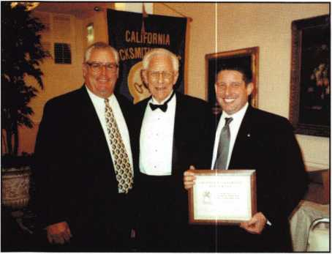

ALOA's Director of Public Policy, Tim McMullen was the  
Keynote Speaker at the California Locksmith Association  
(CLA) Annual Banquet on Saturday, October 26, 2002.  
Shown with Tim is the CLA Executive Director, Kelly  
Rameriz and retireing President Norm Weisenburger (L-R).  
Tim spoke to the group about the ALOA Affiliate Program,  
how ALOA and CLA can work better together, getting new  
members, the future of the industry and legislative outlook  
for 2003.

Joel T. Smith John H. Siemon Kristin L. Carey-Brickler RL

**Leonard J. Wyatt CRL** Mehdi Zahedi CRL Michael L. Finn CML

Norman C. Sterzenbach

Paul W. Hawk

Richard E. Johnson Richard H. Seidel Robert R. Turner

**Ronald** G. **Betschman CML** Stuart H. Rothstein Timothy J. Moore CRL Valerie F. Betschman, CRL Walter C. Crume CRL **William M.** Lockwood, CML **William J. McElheney CML William** L. **Mandlebaum CPL**

OKLAHOMA

Clifford W. Beichner

Frederick D. Stover Larry L. Goodson CRL

OREGON

Andy Hilverda

James G. Jennings CRL

Karl R. Kretsch

Mark T. Roberts

Paul Davis

Rodney E. Thompson CPL

William K. Hamilton

PENNSYLVANIA

Bruce D. Stevenson RL Craig A. Toocheck Dana L. Bamum CML

David A. Schuchart Edward Sellers

Henry R. Lucier James E. Mineard

James R. Bell Jr Jimmie G. McKahan

Joe J. Lee, CRL

Joel T. Ansel Kenneth F. Bowen Loran S. Shive CRL

Louis Picciocchi Nelson T. Dayton CML Richard A. Carr

Ronald E. Weaver Jr, CRL

Sven K. Hellwig Sr

Terry W. Heidler

Thomas J. Demont CML, AHC William J. Kush William B. Neff, CML William L. Young CML William O. Highouse RL

PUERTO RICO

Jose R. Carmona III

SOUTH CAROLINA

Christopher **L.** Melton CPL

Kenneth W. Roberts CML, CPS

Kevin C. Bowers CRL

Kevin R. O'Toole Larry H. Bachman CML

Ryan **L.** Badeaux

TENNESSEE

Chris L. Shook

Gary S. Mooney

Jim Thomas

K Shannon Tilley

Marian M. Swann CRL

Raiford M. Ball CPL

Raymond T. Mason

Robert J. Bosi Jr, CML, CPS

Samuel Williams

Thomas C. Sherwood

Tom G. Gillingham Jr, CML, CPS

Vincent L. Formon **CML, CPS**

TEXAS

Alfred W. Evans

Allen B. Long

Charles H. Saylor

Charles W. Gibson, Jr., CAE

Clifford D. Lipscomb CML, CPS

Craig T. Bednar

David M. Hetherington Jr

David M. Lowell CML, CMST

Gorman Brewer CML

Harold D. Tedford

Henry J. Lachausse IV, CRL, CPS

Howard H. Johnsen

James C. White

James P. Pritchett CPL

John D. Ray

Jonathan R. Miller CML

Kellan A. Warren Larry L. Dickens CRL Michael L. Peurifoy CPL Mike D. Dunkerley

Nicky G. Huff

Olen Cothron CRL Pete N. Wadleigh Randy L. Simpson CML Ruben Beltran CRL Starlin M. Clifford Jr, CML Steve E. Ford CRL Steve L. Cothron Steven N. Graham CML Thomas F. Stern Tim McMullen Vernon E. Sumner Walter F. Taylor Zack Taylor CPL

UTAH

Roger C. Yost CML, CPS

VERMONT

David A. Keenan CRL

Lee K. Accavallo CML

VIRGINIA

David Webb

Edward J. Miller

Elliott P. Connor CRL

Gary R. Baldino CML

James B. Loftus RL

James R. Parker John D. Cannon, CML Raymond B. Fox CPL

Richard D. Rebori Robert Barton Robert L. Wallin Stewart K. Brown III

WASHINGTON

Annsianne S. Burdick Charles C. Robertson CML

Charles D. Beavers

Harold E. Petersen

Harry A. Boyd

Jamie J. Vos

WISCONSIN

Billy B. Edwards Jr, CML

Chuck S. Hegel CRL Jeffrey M. Trepanier RL

John D. Oslund

John F. Engel CRL

John S. Dorsey CML, CPS John W. Soderland, CML, CMST

Laurel M. Grant Len Swan berg Mark D. Fielkow

Martin J. Kitelinger CPL Richard J. Wilczynski CRL Roger F. Coenen Steve Engel CML, CPP

Tim A. Sterr

William A. Cochran CPL William J. Smith RL

WYOMING

Tracey B. Norviel CRL

ARMY EUROPE

Richard E. Leone

Terry L. Loomis CRL

CANADA

David R. Kennedy William W. Price Leonard J. Passarello CPL

Aaron Max Fish

CHINA

Yuen Tiong Lee Yuen-Cheung Chow Yiu-Ping Lam Chan K. Chu

DENMARK

Hans Mejlshede, CML

GERMANY

Adalbert Wendt

JAPAN

Kunihide Kanbe Yoshihisa Osawa Hiroshi Watanabe Yoshihisa Baba Masatoshi Uno Fuyuki Fujiwara Toshihiko Tsukaguchi CRL Hideki Honda Chinaru Inaba Nagao Morimoto

UNITED KINGDOM

Michael Cornette Gary Eckersall



Keynotes • December 2002

**ALOA Scholarship Foundation, Inc.  
Scholarship Application**

3003 Live Oak Street; Dallas TX 75204  
(214) 827-1701, (800) 532-2562

Please print or type **Name**

**Home Address . Home Phone**

**Present Employer .**

**Work Address**

**Work Phone**

**Position**

**PRP/STPRP Level. City**

ALOA/SAVTA#.

**State Zip _**

**Dob**

**Educational Level .**

**(years) Degree, If Any_**

**Supervisor’s Full Name . City**

**State .**

**Zip .**

**Fax**

**FullTime .**

**Part Time**

**Take Home Pay_**

**Length Of Time In Locksmithing**

**Marital Status Number Of Dependents Classes Desired**

**Membership In Trade Associations (List By Name)**

**Household Annual Gross Income .**

**Date Of Classes .**

**Organization Sponsoring Classes: ALOA.**

SAVTA.

**Other.**

**Location .**

Applications will be reviewed by the ASF Selection Committee on an objective and nondiscriminatory basis. All materials and information pertaining to the applicant’s financial status and background shall be held in strict confidence by the Selection Committee.

ALOA Scholarships are granted to selected individuals desirous of entering the locksmithing field or to selected individuals already in the locksmithing field who wish to improve their professional skills through education.

Applications for classes must be received 60 days prior to the date of the class, and will be reviewed as they are submitted. Scholarships for classes at the ALOA or SAVTA convention will be awarded each year at the ALOA Scholarship Foundation meeting preceding the convention and must be received by February 1 each year.

Please attach to this form a letter stating your reason for applying for a scholarship, what you plan to do with the knowledge you obtain and any other information you feel may be helpful to the scholarship board in making its decision. In addition, attach three letters of reference from individuals who have personal knowledge of your background and character. The letters should contain their names, addresses and phone numbers. It would be helpful if at least one of these references is an ALOA or SAVTA member. All scholarship recipients will be required to provide a 3” x 5” photograph of themselves. (Note: Laser prints of digital photographs will not be accepted.)

**Application Checklist**

Only complete applications will be considered for scholarships. An application is considered incomplete unless ALL of the above requested information is received before the deadline: 60 days prior to the classes desired, February 1 for ALOA/SAVTA convention classes. Please send this application after checking off each of the below.

* I have filled in each blank on this form.
* I have written and enclosed a letter explaining my reason for applying.
* I have enclosed three letters of reference.
* I am submitting this in time to be received 60 days prior to the date of a class or by February 1 for ALOA/SAVTA convention classes.
* **I have enclosed a 3” x 5” color photograph.** Note: Laser prints of digital photos will not be accepted.

**Certification Of Applicant**

I certify that the information contained herein, and all supplemental forms are complete and correct to the best of my knowledge. I further certify that if I am selected as a scholarship recipient I will use the knowledge gained for the improvement, development and advancement of the locksmithing profession. Also, if asked by an authorized ASF official, I agree to give proof of the information that I have given on this application. I also understand that this proof my include copies of my previous year’s Federal Tax Return. I also understand that if no proof is given when requested, I may not receive consideration for an ALOA Scholarship Award. I understand that this application is valid only for the event/class specified.

SignatureDate

Please send all completed applications to:

ALOA Scholarship Foundation, Inc. • 3003 Live Oak Street • Dallas, TX 75204

Revised 12/02

Classified Advertising Policy

Classified advertising space is provided free of charge to ALOA members, and fora fee of $.60 per word', $15 minimum for non-members. Classified ads may be used to advertise  
used merchandise and overstocked items for sale, "wanted to buy" items, business opportunities, employment opportunities/positions wanted and the like. Members or non-members wishing  
to advertise services or new merchandise for sale may purchase a "Commercial Classified Ad," for a fee of $ 1.30 per word, with a minimum of $40. Each ad will run for two issues. For blind  
boxes there is a $5 charge to members and non-members. All ads must be submitted in writing to the ALOA office by the fifteenth of the month, two months prior to issue date. Send to  
Keynotes Classifieds, 3003 Live Oak St., Dallas TX 75204-6186. ALOA reserves the right to refuse any classified advertisement that it deems inappropriate according to the stated purpose

of the classified advertising section.

EMPLOYMENT

LOOKING FOR A CHANGE?

We are currently looking for a Shop Manger. Duties include running daily operations, scheduling, dispatching, hiring and training. We're also looking for experienced Road Techs and Apprentices. We are a growing company and we are looking for individuals with a positive attitude and good work ethic.

We take pride in our employees and they are compensated well. We offer a complete benefits package, including 401 (k).

If this looks like something you may be interested in, send or fax your resume to:

McCausland Lock and Alarm 1 101 Lincoln Ave. • Prospect Park, PA 19076 Phone: 610/522-1935 • Fax: 610/532-8173 e-mail: mac 101 [l@aol.com](mailto:l@aol.com) • Attn: Tom McCausland

LOCKSMITH WANTED

Relocate to Houston. Knowledgeable Locksmiths earn $3,000 per month. Call 281/830-9441.

ACCOUNT EXECUTIVE WANTED

We are seeking an energetic, experienced sales professional to join our rapidly growing team. Candidate must possess a strong background in commercial hardware as well as electron­ic access control, (CCTV and alarm experience is a plus!). Minimum 5 years sales experience required. We offer: Top wages, commission, expense account, 401 (k), paid vacations and holiday, hospitalization. E-MAIL resume to: [rmesnick@bass- security.com](mailto:rmesnick@bass-security.com) or phone-216/755-1 200 ext# 128.

STOP LOOKING!!!!!

EXPERIENCED TECHNICIANS WANTED

Lock into your future now!

If you are experienced, intelligent, and desire a secure future, come join our team. We are a full service commercial/residen- tial security service (locks,keys,safes,cctv,access control, door related hardware). We offer: sign on bonus, top wages, company vehicle, 401k, paid vacation, paid holidays, new uniforms, cross training, and job satisfaction. We are looking for the best tech's, who are ready to be treated and compensated as professionals.

Bass Security Services, Inc.

Ph#: 216/755-1200 ex.# 128

Fax#: 216/755-1220

E-MAIL: [rmesnick@bass-security.com](mailto:rmesnick@bass-security.com)

EXPERIENCED LOCKSMITH

Established and expanding company in central NJ is seeking experienced help in residential/commercial/auto/access control/safe work. Top pay for top mechanics, along with medical, dental, paid vacation, two days off per week, and no night calls.

Apple Locksmith 4030 Route 9 South Morganville, NJ 07751 732/970-1500

or fax resume to 732/970-9725 (attn: Andy or Jack)

Keynotes • December 2002

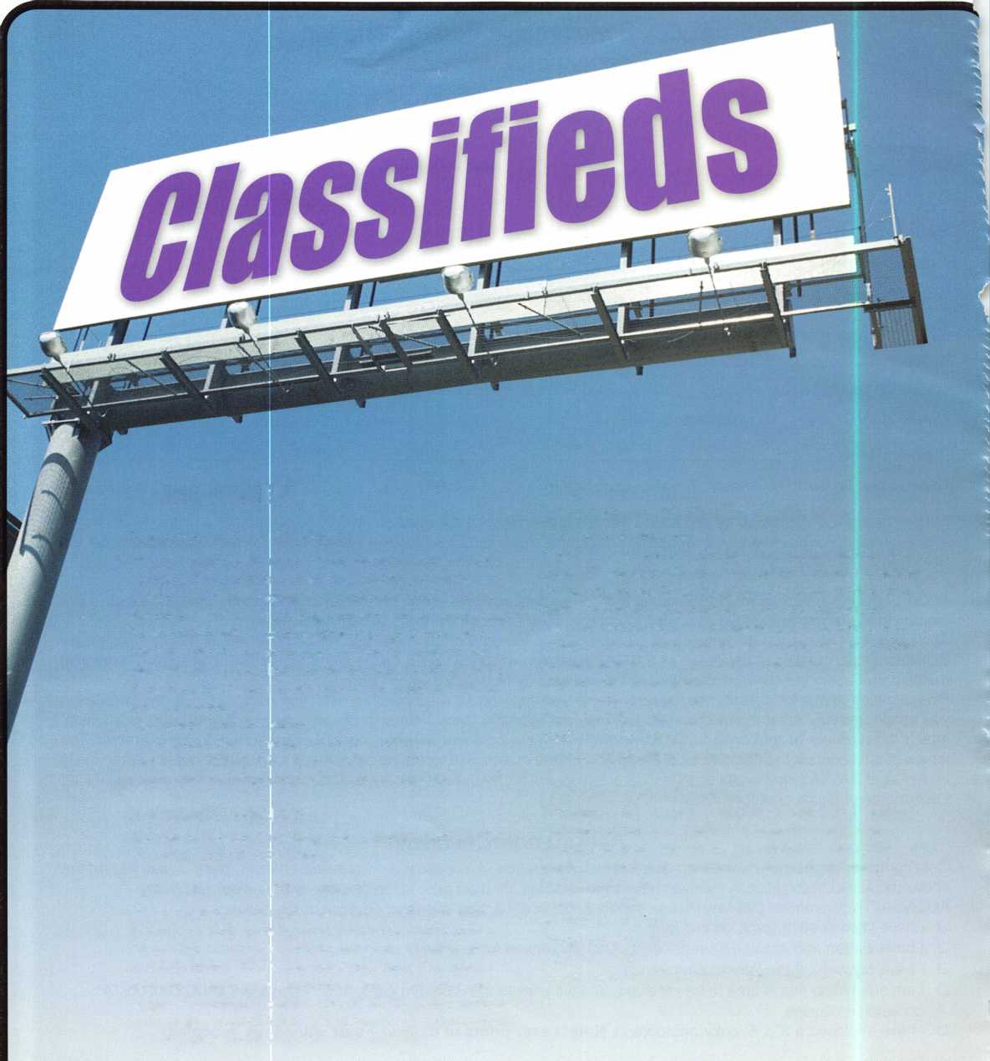

AUTOMOTIVE LOCKSMITH WANTED

Relocate to South Florida and throw away your deadbolts and three keys for a dollar.

We run over 300 calls per week. You must own a truck with tools and code equipment to cut all foreign and domestic keys. You can earn $800 to $1500 per week. South Florida Lock and Safe. 800/9280-2926. Please if no truck or tools, no calls.

WANTED TO BUY/SELL

NEED AUTO INFO?

Do you do exotic autos? If you are called to pro­vide keys for a Panoz Espirante, Here is contact info for the company - they provided key codes, transponder codes and are very helpful:

Panoz Auto Development Company

1101 Highway 1 24

Hoschton, Georgia 30548

Tel: (770) 867-4796

Toll Free: 1-888-GOPANOZ (467-2660)

Fax: (770) 307-1714

E-mail: [panozauto@panozauto.com](mailto:panozauto@panozauto.com)

NEED CASH?

Have you recently sold your locksmith business, or are you selling it now? We can give you a lump sum of cash now for all or a portion of your remaining payments. RED OAK FUNDING. 630/483-0335.

BARGAIN OF THE CENTURY FOR SALE

* 4-drawer fireproof file cabinets, all 350 degree, one hour, perfect condition
* 5 Fireking with Medeco locks
* 3 Schwab
* 1 Hercules by Meilink
* 1 Diebold
* 1 Meilink

For further details, call Allied Locksmiths (954/704-8215), or e-mail to [alliedlock@aol.com](mailto:alliedlock@aol.com).

OVERSTOCK, NEW VON DUPRIN 4 E99K US26 3' $ 525 ea.

1. 22TP F 3' 689 $250 ea.
2. 3347TL 3' US26D $720 ea.

I have more 9947,3347,2227,9975 for sale. Please call Kevin at 915-553-3145 or e mail: [reddog2501@excite.com](mailto:reddog2501@excite.com) .

**Magnetic Locking Systems with  
More Than Fasteners  
BfeL** t **for Support.**

^ li|jj DynaLock electromagnetic

lH T I You get product support and

p {j i p engineering services that

i) / / JF technical and application

assistance to system design and  
specification work.

DynaLock UL Listed high security products are manufactured using computerized  
machining centers and robotics for superior quality, tight control and timely delivery.  
Full, internal production capacity ensures lead time on standard products of days...  
not weeks. And each fully tested magnetic lock ships with a ten year warranty.

Standard maglocks, Passive Infrared, Delayed Egress and Low Profile DynaLock  
systems offer holding forces from 650 to 1500 lbs. Accessory products include UL  
listed power supplies, keypad systems, keyswitches, exit controls, timers, monitor

stations and custom consoles.

Don’t settle for just a  
lock... Get more than  
maglocks with DynaLock.

Call today:

**877-DYNALOCK  
(877-396-2562) ^**

FT -■■■:

or visit:

dynalock.com

low.

***Electromagnetic Locking Systems***

DynaLock Corporation

705 Emmett Street, P.0. Box 2728  
Bristol, CT 06011-2728  
Fax: 860/585-0338  
[info@dynalock.com](mailto:info@dynalock.com)

Keynotes • December 2002

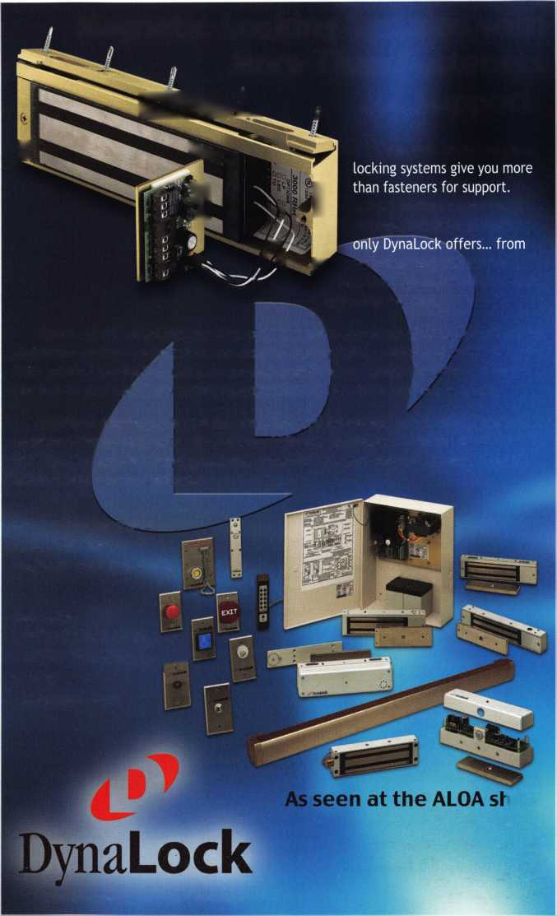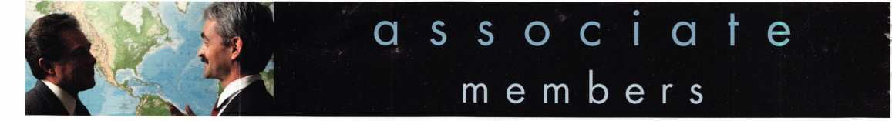

Distributor

ADI Inc.

Phone: 631-692-1000 Fax: 631-692-3011

Accredited Lock Supply Co.

Phone: 201-865-5015 Fax: 201-865-0030 [www.acclock.com](http://www.acclock.com)

Ace Lock & Security Supply

Phone: 908-688-7666 Fax: 908-688-2442 [www.acelock.com](http://www.acelock.com)

Action Hardware Inc.

Phone: 800-662-6695 Fax: 800-930-2329

Andrews Wholesale Lock Supply

Phone: 717-272-7422 Fax: 717-274-8659 [www.andrewslock.com](http://www.andrewslock.com)

Boyle & Chase Inc.

Phone: 800-325-2530 Fax: 800-205-3500 [www.boyleandchase.com](http://www.boyleandchase.com)

Clark Security Products

Phone: 800-854-2088 Fax: 619-974-5284 [www.clarksecurity.com](http://www.clarksecurity.com)

Cook's Building Specialties

Phone: 505-883-5701 Fax: 505-883-5704

Dire's Lock & Key Company

Phone: 303-294-0176 Fax: 303-294-0198

Direct Security Supply, Inc.

Phone: 800-252-5757 Fax: 800-452-8600

Doyle Security Products

Phone: 800-333-6953 Fax: 612-521-0166 [www.doylesecurity.com](http://www.doylesecurity.com)

Dugmore and Duncan, Inc.

Phone: 888-384-6673 Fax: 888-329-3846

E. L. Reinhardt Co., Inc.

Phone: 800-328-131 1 Fax: 651-481-0166 [www.elreinhardt.com](http://www.elreinhardt.com)

Ewert Wholesale Hardware

Phone: 800-451-0200 Fax: 708-597-0881

Fairway Supply, Inc.

Phone: 214-350-0021 Fax: 214-352-4299 [www.fairwaysupply.com](http://www.fairwaysupply.com)

Foley-Belsaw Company

Phone: 800-821-3452 Fax: 816-483-5010 [www.foley-belsaw.com](http://www.foley-belsaw.com)

Fried Brothers Inc.

Phone: 800-523-2924 Fax: 215-592-1255 [www.fbisecurity.com](http://www.fbisecurity.com)

H L Flake Co.

Phone: 800-231-4105 Fax: 713-926-3399 [www.hlflake.com](http://www.hlflake.com)

H.S. & S. Wholesale Distrib.

Phone: 313-342-6777 Fax: 313-342-7580

Hans Johnsen Company

Phone: 214-879-1550 Fax: 214-879-1530 [www.hjc.com](http://www.hjc.com)

Hardware Agencies, Ltd.

Phone:416-462-1921

[www.hardwareagencies.com](http://www.hardwareagencies.com)

Howard Keys

Phone: 704-509-4944 Fax: 704-509-6248 www. howa rd keys .com

IDN Incorporated

Phone: 817-421-5470 Fax: 817-421-5468 [www.idn-inc.com](http://www.idn-inc.com)

Intermountain Lock & Supply

Phone: 800-453-5386 Fax: 801-485-7205 [www.intermountainlock.com](http://www.intermountainlock.com)

Jo Van Distributors

Phone:416-752-2238

Fax:416-752-7282

[www.jovanlock.com](http://www.jovanlock.com)

Lockmasters, Inc.

Phone: 859-885-6041 Fax: 859-885-7093 [www.lockmasters.com](http://www.lockmasters.com)

Locks Company

Phone: 800-288-0801 Fax: 305-949-3619

Locksmith Ledger International

Phone: 770-886-0800 Fax: 770-889-7703 [www.lledger.com](http://www.lledger.com)

M. Zion Company

Phone: 212-349-8677 Fax: 212-964-0495 [www.mzion.com](http://www.mzion.com)

McDonald Dash Locksmith Supply

Phone: 800-238-7541 Fax: 901-366-0005 [www.mcdonalddash.com](http://www.mcdonalddash.com)

McManus Locksmith Supply, Inc.

Phone: 704-333-9112 Fax: 704-332-8664

Monaco Lock Co.

Phone: 800-526-6094 Fax: 800-845-5625 [www.monacolock.com](http://www.monacolock.com)

Omaha Wholesale Hardware

Phone: 800-238-4566 Fax: 402-444-1664 [www.omahawh.com](http://www.omahawh.com)

Phoenix Safe International LLC

Phone: 765-483-0954 Fax: 765-483-0962 [www.phoenixsafeusa.com](http://www.phoenixsafeusa.com)

Professional Business Products

Phone: 248-360-3979

Fax: 248-360-3982

[www.professionalbusinessproducts](http://www.professionalbusinessproducts).

RA-Lock Company

Phone: 972-775-6301 Fax: 972-775-6316 [www.ralock.com](http://www.ralock.com)

SecureRite.Com

Phone: 800-241-3930 Fax: 858-974-5269 [www.SecureRite.Corn](http://www.SecureRite.Corn)

Sentry Security Fasteners

Phone: 309-693-2800 Fax: 800-693-2872

Somerset Security Products

Phone: 800-881-5206 Fax: 800-206-9949

Southern Lock and Supply Co.

Phone: 727-541-5536 Fax: 727-544-8278 [www.southernlock.com](http://www.southernlock.com)

Stone & Berg Wholesale

Phone: 800-225-7405 Fax: 800-535-5625

The Locksmith Store Inc.

Phone: 847-364-5111 Fax: 847-364-5125 [www.locksmithstore.com](http://www.locksmithstore.com)

Timemaster Inc.

Phone: 859-259-1878 Fax: 859-255-0298 [www.time-master.com](http://www.time-master.com)

Top Notch Distributors, Inc.

Phone: 800-233-4210 Fax: 800-854-4146 [www.4topnotch.com](http://www.4topnotch.com)

U.S. Lock Corp.

Phone: 800-925-5000 Fax: 800-338-5625 [www.uslock.com](http://www.uslock.com)

Manufacturer

A & B Safe Corporation

Phone: 800-253-1267 Fax: 856-863-1208 [www.a-bsafecorp.com](http://www.a-bsafecorp.com)

ABUS Lock Company

Phone: 800-352-2287 Fax: 602-595-3499 [www.abus.com](http://www.abus.com)

Abloy Door Security

Phone: 800-465-5761 Fax: 514-335-0430 [www.abloy.com](http://www.abloy.com)

Adams Rite Mfg. Company

Phone: 800-872-3267 Fax: 800-232-7329 [www.adamsrite.com](http://www.adamsrite.com)

Adesco Safe Mfg. Company

Phone: 800-821-6803 Fax: 562-408-6427 [www.adesco.com](http://www.adesco.com)

Adrian Steel Company

Phone: 800-677-2726 Fax: 517-265-5834 [www.adriansteel.com](http://www.adriansteel.com)

Alarm Lock Systems Inc.

Phone: 800-252-5625 Fax: 516-789-3383 [www.alarmlock.com](http://www.alarmlock.com)

All Five Tool Company, Inc.

Phone: 860-583-1691 Fax: 860-583-4516 [www.all5tool.com](http://www.all5tool.com)

American Lock Company

Phone: 708-534-2000 Fax: 708-534-0531 [www.armericanlock.com](http://www.armericanlock.com)

American Security Products

Phone: 909-685-9680X1083 Fax: 909-685-9685 [www.amsecusa.com](http://www.amsecusa.com)

BWD Automotive

Phone: 334-872-6524 Fax: 334-874-6011

[www.bwdautomotive.com](http://www.bwdautomotive.com)

Baldwin Hardware

Phone: 610-796-4012 Fax: 610-796-4493 [www.baldwinhardware.com](http://www.baldwinhardware.com)

Be-Tech Security Systems Ltd.

Phone: 852-231-67447 www. be-tec h. com. h k

Buddy Products

Phone: 800-886-8688 Fax: 312-733-8356 [www.buddyproducts.com](http://www.buddyproducts.com)

COMPX Security Products

Phone: 864-297-6655 Fax: 864-297-9987 [www.nclnet.com](http://www.nclnet.com)

Curtis Industries,

A Barnes Distr.

Phone: 800-555-5397 Fax: 800-867-6020 [www.curtisindustries.com](http://www.curtisindustries.com)

g

2

Keynotes • December 2002

**associate**

**members**

D&D Technologies (USA), Inc.

Phone: 714-677-1300 x292 Fax: 714-677-1299 [www.ddtechusa.com](http://www.ddtechusa.com)

DETEX Corporation

Phone: 800-729-3839 Fax: 830-620-6711 [www.detex.com](http://www.detex.com)

DORMA

Architectural Hardware

Phone: 717-336-3881 Fax: 717-336-3500 [www.dorma-usa.com](http://www.dorma-usa.com)

Don-Jo Manufacturing, Inc.

Phone: 978-422-3213 Fax: 978-422-3467 [www.don-jo.com](http://www.don-jo.com)

Door Controls International

Phone: 800-742-3634 Fax: 800-742-0410 [www.doorcontrols.com](http://www.doorcontrols.com)

ESP Lock Products Inc.

Phone: 978-562-3481 Fax: 978-562-9859

FireKing Security Products

Phone: 800-457-2424 Fax: 800-896-6606 [www.fireking.com](http://www.fireking.com)

HES, Inc.

Phone: 623-582-4626 Fax: 623-582-4641 [www.hesinnovations.com](http://www.hesinnovations.com)

HPC, Inc.

Phone: 847-671-6280 Fax: 847-671-6343 [www.hpcworld.com](http://www.hpcworld.com)

Hongtai Lock Co. Ltd.

Phone: 137-238-1414 Fax: 208-793-3856

INTELLIKEY Corp.

Phone: 800-226-0703 Fax: 321-724-0811 [www.intellikey.com](http://www.intellikey.com)

llco Unican

Phone: 252-446-3321 Fax: 252-446-4702 [www.kaba-ilco.com](http://www.kaba-ilco.com)

Jet Hardware Mfg., Co.

Phone: 718-257-9600 Fax: 718-257-0973 [www.jetkeys.com](http://www.jetkeys.com)

KABA High Security Locks

Phone: 860-621-3601 Fax: 860-621-9727 [www.kabausa.com](http://www.kabausa.com)

KEY-BAK/West Coast Chain Mfg.

Phone: 909-923-7800 Fax: 909-923-0024 [www.keybak.com](http://www.keybak.com)

Keri Systems Inc.

Phone: 408-451-2520 Fax: 408-441-0309 [www.kerisys.com](http://www.kerisys.com)

Knaack Manufacturing Co.

Phone: 800-456-7865 Fax: 815-459-9097 [www.weatherguard.com](http://www.weatherguard.com)

LAB Security

Phone: 800-243-8242 Fax: 860-583-7838 [www.labpins.com](http://www.labpins.com)

LCN Closers/Div. of Ingersoll

Phone: 815-875-3311 Fax: 815-879-1497 [www.lcnclosers.com](http://www.lcnclosers.com)

La Gard Inc.

Phone: 310-325-5670 Fax: 310-325-5615 [www.lagard.com](http://www.lagard.com)

Lucky Line Products, Inc.

Phone: 858-549-6699 Fax: 858-549-3241 [www.luckyline.com](http://www.luckyline.com)

M.A.G. Security

Phone: 714-891-5100 Fax: 714-892-6845 [www.magsecurity.com](http://www.magsecurity.com)

MARKS, U.S.A.

Phone: 516-225-5400 Fax: 516-225-6136 [www.marksusa.com](http://www.marksusa.com)

MARRAY ENTERPRISES

Phone: 408-970-0213 Fax: 408-970-8767 [www.marray.com](http://www.marray.com)

MCS Communication Systems

Phone: 514-444-2040 Fax: 514-444-2029 [www.mcscommunication.com](http://www.mcscommunication.com)

MMD, Inc.

Phone: 865-428-3611 Fax: 865-453-4136

MUL-T-LOCK USA, Inc.

Phone: 800-562-3511 Fax: 973-778-4007 www. mul-t-lock.com

Master Lock Company

Phone: 414-444-2800 Fax: 414-444-0322 [www.masterlock.com](http://www.masterlock.com)

Medeco Security Locks

Phone: 540-380-5000 Fax: 540-380-5010 [www.medeco.com](http://www.medeco.com)

NKL Industries Inc

Phone: 800-528-9900

Fax: 757-485-0271

[www.nklindustries.com/products_NK](http://www.nklindustries.com/products_NK)

Pro Steel

Phone: 801-373-2385 Fax: 801-373-2399 [www.prosteel.us](http://www.prosteel.us)

ROFU International Corp

Phone: 800-255-7638 Fax: 253-922-1728 [www.rofu.com](http://www.rofu.com)

Rutherford Controls Int'l. Co.

Phone: 757-427-1230 Fax: 757-427-9549 [www.rutherfordcontrols.com](http://www.rutherfordcontrols.com)

STRATTEC Security Corp.

Phone:414-247-3415 Fax: 414-247-3692 [www.strattec.com](http://www.strattec.com)

Sargent & Greenleaf, Inc.

Phone: 859-885-9411 Fax: 859-885-3063 [www.sargentandgreenleaf.com](http://www.sargentandgreenleaf.com)

Sargent Manufacturing Co.

Phone: 203-562-2151 Fax: 203-776-5992 [www.sargentlock.com](http://www.sargentlock.com)

Schlage Lock Co.

Phone: 719-264-5300 Fax: 719-264-5382 [www.schlagelock.com](http://www.schlagelock.com)

Schwab Corp

Phone: 765-447-9470 Fax: 765-447-8278 [www.schwabcorp.com](http://www.schwabcorp.com)

Securitron Magnalock Corp.

Phone: 775-355-5626 Fax: 775-355-5636 [www.securitron.com](http://www.securitron.com)

Security Door Controls

Phone: 805-494-0622 Fax: 805-494-8861 [www.sdcsecurity.com](http://www.sdcsecurity.com)

Security Solutions

Phone: 405-376-1600 Fax: 405-376-6870 [www.securitysolutions-usa.com](http://www.securitysolutions-usa.com)

Sully Tools Inc.

Phone: 703-689-3416 Fax: 703-787-0869 [www.sullytools.com](http://www.sullytools.com)

Sun Safes Manufacturing Co.

Phone: 823-194-59300 Fax: 823-194-59400 [www.eaglesafes.com](http://www.eaglesafes.com)

Taylor Security & Lock

Phone: 301-948-7670 Fax: 301-948-1029 [www.taylorsecurity.com](http://www.taylorsecurity.com)

Taymor Industries, Inc.

Phone: 800-388-9887 Fax: 800-288-8133

Trine Access Technology

Phone: 718-829-2332 Fax: 71 8-829-6405 [www.trineonline.com](http://www.trineonline.com)

Victor E-lok, Inc.

Phone: 949-786-0133 Fax: 949-786-0133

Videx Inc.

Phone: 541-758-0521 Fax: 541-752-5285 [www.videx.com](http://www.videx.com)

W-LOK Corporation

Phone: 616-355-4015 Fax: 616-355-4295 [www.wlokcorp.com](http://www.wlokcorp.com)

Yale Security Group, Inc.

Phone: 800-438-1951 Fax: 800-338-0965

Service Organization

1-800 Locksmith 1994 Inc.

Phone: 800-562-5764 Fax: 718-236-4504 www. 1 800locksmith.net

Allstate Insurance Company

Phone: 847-402-8196 Fax: 847-326-7509 [www.allstate.com](http://www.allstate.com)

Emergency Road Service Inc.

Phone: 888-839-5386 Fax: 678-277-8105

Massglass & Door Service

Phone: 888-742-8837 Fax: 818-991-5742 [www.massglass.com](http://www.massglass.com)

The National Locksmith

Phone: 630-837-2044 Fax: 630-837-1210 [www.thenationallocksmith.com](http://www.thenationallocksmith.com)

The Security Professionals

Phone: 866-486-1938

Fax: 856-486-0401

[www.thesecurityprofessionals.com](http://www.thesecurityprofessionals.com)

Webster Safe & Lock Co., Inc.

Phone: 901-332-2911 Fax: 901-332-2878 [www.webstersinc.com](http://www.webstersinc.com)

Keynotes • December 2002

back page

About the Authors

Paul F. Chandler, CRL manages the electronic security products division of I.D.N. -Acme. Paul earned his jour­neyman electrician license in Massachusetts in 1983, and passed the PRP in 1987. He has experience in CCTV, alarms access control systems, high security locks and safes. Paul has written for several trade magazines and was the Keynotes Author of the Year for 1998. Paul's classes on access control and basic electricity have been enjoyed by locksmiths throughout the southwest.

John Dorsey, CML, CPS, owns and operates Fast Safe and Lock in Au Claire, Wisconsin.

Sal Dulcamaro, CML, has been in the security industry for over 27 years. He is the president of All Pro Security, Inc. in Michigan and has been an ALOA member for 20 years. A past president of the Locksmith Security Association of Michigan, Sal currently serves as web edi­tor of the association's on-line newsletter. He was named Keynotes "Author of the Year" in both 1996 and 1997. He is also a contributing editor for Keynotes. Find Sal on the Internet at: <http://www.home.earthlink.net/-lockwriter>.

Greg Perry, CML, CPS has been in the locksmith indus­try for 20 years. He's spent half of that time as a field technician for Security Engineering in Ridgecrest, CA. Greg is also a past president of the Desert Counties Chapter of the California Locksmiths Association. He has also won the 2002 Keynotes Author of the Year Award. You can e-mail him at [glmperry@iwvisp.com](mailto:glmperry@iwvisp.com).

David E. Thielen, CML is the lockshop manager for Adams Twelve Five Star School District, Broomfield, Colorado. He has been a professional locksmith for more than 15 years a member of RMLA and DHI and a member of ALOA since 1985. He has instructed classes for the Rocky Mountain Locksmiths Association and has devel­oped and instructed ACE certified classes for ALOA at regional and national conventions.

|  |  |
| --- | --- |
| r |  |
| Ad Index |  |
| ALOA 2003 Inside Front Cover | |
| Sanzo Specialties | 1 |
| STAM | 5 |
| DHI | 7 |
| Professional  Business Products | 9 |
| Fox Valley Technical College . | ...11 |
| A&B Safe | ...23 |
| TLA | ...35 |
| Dynalock | ...41 |
| SAFETECH  2003 Inside back Cover | |
| L |  |



Keynotes • December 2002

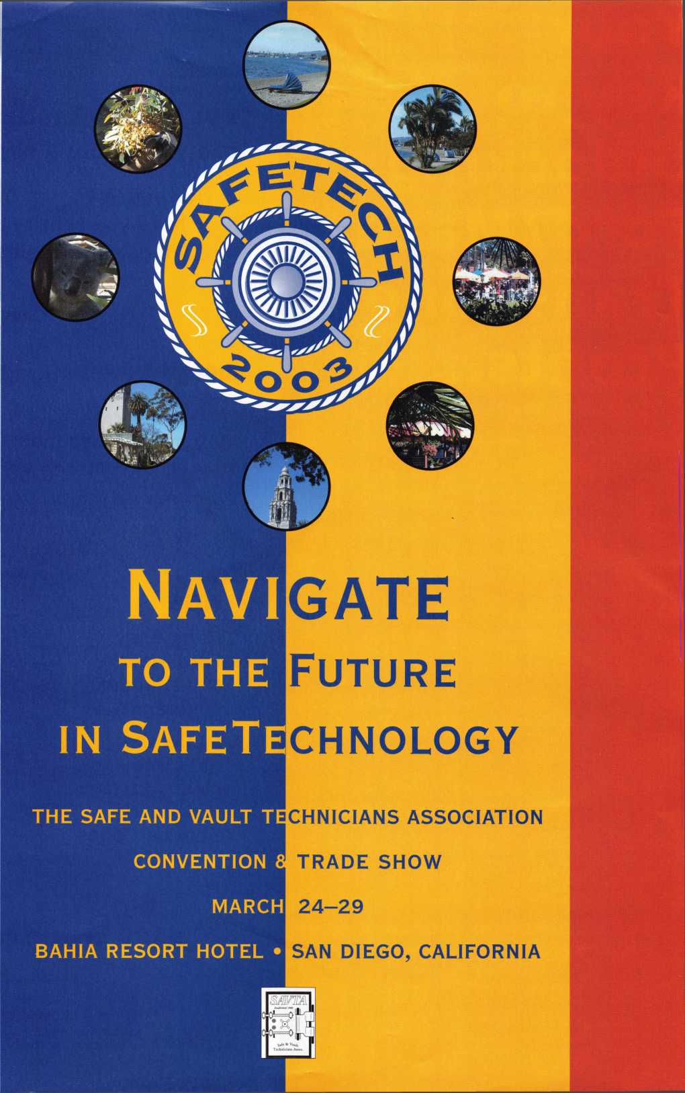

**You're never on**

**your own..**

**Toll Free Tech Support**

"I've lost my Taurus keys...  
can you make a new set?"

How much of your money

Jr

have you sent to the W local Ford dealer?

8008LA New Generation STAR

Use the Ford factory tool to  
program transponder keys for  
ALL Ford/Mazda vehicles.

Keep the money in your pocket!

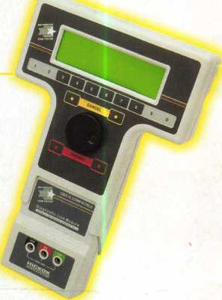

NGS

Complete

Ford/Mazda

transponder

coverage

PLUS the

ability to clear ALL

Diagnostic

Service Codes

Say "YES" to  
$100 phone calls

o

**1**-**800**-**342-5080**

for more information visit

**[www.hickok-inc.com](http://www.hickok-inc.com)**



**HICKOK**

INCORPORATED

